IT & CYBER
INTERNSHIP PROGRAM
6-Week
Foundation + Specialization Learning Path
20 Interns · 5 Specialization Tracks · 2-Week Common Foundation
NOC · SOC · Cloud (OpenStack) · Red Team / Pentesting · Cyber R&D
Curriculum · Hands-on labs · Weekly KPIs · Capstone Projects
Prepared By Adil Shafiq – Manager Cloud & Security
July 2026

Table of Contents
Table of Contents 2
1. Program Overview 7
1.1 Program Structure at a Glance 7
1.2 The Two Phases 8
Phase 1 — Common Foundation (Weeks 1–2) 8
Phase 2 — Specialization (Weeks 3–6) 8
1.3 How to Read This Roadmap 8
2. Phase 1 — Common Foundation (Weeks 1–2) 9
2.1 Learning Objectives 9
2.2 Foundation Roadmap 9
2.3 Topic Breakdown 10
2.3.1 Operating Systems — Linux 10
2.3.2 Networking Fundamentals 10
2.3.3 Programming — Python 10
2.3.4 Version Control — Git & GitHub 11
2.3.5 Cybersecurity Fundamentals 11
2.3.6 Virtualization & Containers 12
2.3.7 Professional Skills 12
2.4 Week 1 Daily Schedule 13
2.5 Week 2 Daily Schedule 13
2.6 Weekly Assessment Checkpoints 13
2.7 Mini-Project — End of Week 2 14
"Secure Small Network + Automation Toolkit" 14
3. Phase 2 — Specialization Overview (Weeks 3–6) 15
3.1 How Track Selection Works 15
3.2 Track Comparison 15
4. Track 1 — NOC (Network Operations Center) 16
4.1 Learning Objectives 16
4.2 Required Tools 16
4.3 Track Roadmap 17
4.4 Topic Breakdown 18
4.4.1 Cisco & Enterprise Networking 18
4.4.2 Switching, VLANs & STP 18
4.4.3 Routing Protocols (OSPF) 18
4.4.4 ACLs & NAT 19
4.4.5 Firewalls & VPN 19
4.4.6 DNS / DHCP Services 19
4.4.7 Network Monitoring 19
4.4.8 Network Troubleshooting 20
4.5 Weekly Milestones 21
4.6 Sample Daily Activities 21
4.7 Mini-Projects 21
Mini-Project 1: Segmented, Access-Controlled Network (end of Week 4) 21
Mini-Project 2: Secure Branch-to-HQ Connectivity (end of Week 5) 21
4.8 Assessment Checkpoints 22
4.9 Capstone Project 22
Design, Deploy, Monitor & Troubleshoot an Enterprise Network 22
4.10 Career Outcomes 22
5. Track 2 — SOC (Security Operations Center) 23
5.1 Learning Objectives 23
5.2 Required Tools 23
5.3 Track Roadmap 24
5.4 Topic Breakdown 25
5.4.1 Blue Team & SOC Operations 25
5.4.2 Log Analysis & SIEM 25
5.4.3 MITRE ATT&CK & Threat Hunting 25
5.4.4 Sigma Rules & Detection Engineering 25
5.4.5 Incident Response 26
5.4.6 IOC Analysis & Malware Basics 26
5.4.7 Endpoint Monitoring 26
5.4.8 Threat Intelligence 27
5.5 Weekly Milestones 28
5.6 Sample Daily Activities 28
5.7 Mini-Projects 28
Mini-Project 1: Five Custom Detection Rules (end of Week 4) 28
Mini-Project 2: End-to-End Incident Report (end of Week 5) 28
5.8 Assessment Checkpoints 29
5.9 Capstone Project 29
Build a SOC Lab that Detects, Investigates & Reports Simulated Attacks 29
5.10 Career Outcomes 29
6. Track 3 — Cloud (OpenStack) 30
6.1 Learning Objectives 30
6.2 Required Tools 30
6.3 Track Roadmap 31
6.4 Topic Breakdown 32
6.4.1 Cloud Computing Fundamentals 32
6.4.2 OpenStack Architecture & Core Services 32
6.4.3 Deployment: DevStack & Kolla-Ansible 32
6.4.4 Networking, Security Groups & Floating IPs 32
6.4.5 Horizon, Heat & Orchestration 33
6.4.6 Advanced Services 33
6.4.7 High Availability & Multi-Node 33
6.4.8 Infrastructure as Code + Monitoring 34
6.5 Weekly Milestones 35
6.6 Sample Daily Activities 35
6.7 Mini-Projects 35
Mini-Project 1: Networked, Access-Controlled Tenant (end of Week 4) 35
Mini-Project 2: Heat-Templated Stack on a Multi-Node Cloud (end of Week 5) 35
6.8 Assessment Checkpoints 36
6.9 Capstone Project 36
Deploy & Secure a Production-Style Multi-Node OpenStack Cloud 36
6.10 Career Outcomes 36
7. Track 4 — Cybersecurity (Red Team / Pentesting) 37
7.1 Learning Objectives 37
7.2 Required Tools 37
7.3 Track Roadmap 38
7.4 Topic Breakdown 39
7.4.1 Reconnaissance & OSINT 39
7.4.2 Scanning & Enumeration (Nmap) 39
7.4.3 Web Exploitation (Burp Suite / OWASP Top 10) 39
7.4.4 Active Directory Basics 39
7.4.5 Privilege Escalation (Linux & Windows) 40
7.4.6 Password Attacks 40
7.4.7 Exploitation Frameworks 40
7.4.8 Reporting & Communication 41
7.5 Weekly Milestones 42
7.6 Sample Daily Activities 42
7.7 Mini-Projects 42
Mini-Project 1: Web Application Compromise Report (end of Week 4) 42
Mini-Project 2: Full Privilege-Escalation Chain — Linux & Windows (end of Week 5) 42
7.8 Assessment Checkpoints 43
7.9 Capstone Project 43
Full Penetration Test of a Lab Environment + Professional Report 43
7.10 Career Outcomes 43
8. Track 5 — R&D (Research & Development) 44
8.1 Learning Objectives 44
8.2 Required Tools 44
8.3 Track Roadmap 45
8.4 Topic Breakdown 46
8.4.1 Domain Orientation & Research Methodology 46
8.4.2 Domain: Artificial Intelligence & LLMs 46
8.4.3 Domain: Android Development 46
8.4.4 Domain: iOS Development 47
8.4.5 Domain: DevSecOps 47
8.4.6 Domain: Automation Engineering 47
8.5 Weekly Milestones 48
8.6 Sample Daily Activities 48
8.7 Mini-Projects 48
Mini-Project 1: Smallest Working Prototype (end of Week 4) 48
Mini-Project 2: Feature-Complete Prototype (end of Week 5) 48
8.8 Assessment Checkpoints 49
8.9 Capstone Project 49
Innovative Prototype — AI App, Mobile App, DevSecOps Pipeline, Automation Framework, or Research Demo 49
8.10 Career Outcomes 49
9. Intern KPI & Evaluation Templates 50
9.1 KPI Framework Overview 50
9.2 Weekly Intern KPI Scorecard (Universal — All Tracks) 51
9.3 Track-Specific Technical KPI Add-ons 52
Track 1 — NOC 52
Track 2 — SOC 52
Track 3 — Cloud (OpenStack) 52
Track 4 — Red Team 52
Track 5 — R&D 53
9.4 Mini-Project Evaluation Rubric (Template) 54
9.5 Capstone Project Evaluation Rubric 55
9.6 Mid-Internship Review Form (End of Week 4) 56
9.7 Final Internship Performance Scorecard & Certificate Eligibility 57
Certificate Eligibility Threshold 57
9.8 Intern Self-Assessment Template (Weekly, Optional but Recommended) 58
9.9 Mentor / Supervisor Weekly Feedback Template 59
9.10 KPI Rating Scale & Grade Conversion 60
10. Appendices 61
Appendix A — Consolidated Master Resource List 61
Official Documentation 61
Free Courses & Learning Platforms 63
Hands-On Practice Platforms 63
Repositories 63
Certifications (Optional) 64
Appendix B — Required Tools & Software Checklist 65
Phase 1 — All Interns 65
Track 1 — NOC 65
Track 2 — SOC 65
Track 3 — Cloud (OpenStack) 65
Track 4 — Red Team 66
Track 5 — R&D 66
Appendix C — Glossary of Acronyms 67

1. Program Overview
This roadmap lays out a 6-week, two-phase learning path for interns entering a IT & Cyber Internship Program. It is built in the visual style of colour-coded topic nodes, clear prerequisite flow, hands-on labs at every step, and curated external resources for deeper learning.
Field | Detail
Total Duration | 6 weeks (2 weeks Common Foundation + 4 weeks Specialization)
Total Interns | 20
Target Audience | Final-year university students or fresh graduates — beginner to intermediate technical level
Program Goal | Prepare interns for real-world industry roles through structured learning, extensive hands-on labs, and project-based learning
Learning Model | Phase 1: shared curriculum for all interns → Phase 2: 5 specialization tracks selected by fit & interest
Assessment Model | Daily labs, weekly quizzes, weekly KPI scorecards, mini-projects, and a final capstone per track (see Section 9)

1.1 Program Structure at a Glance
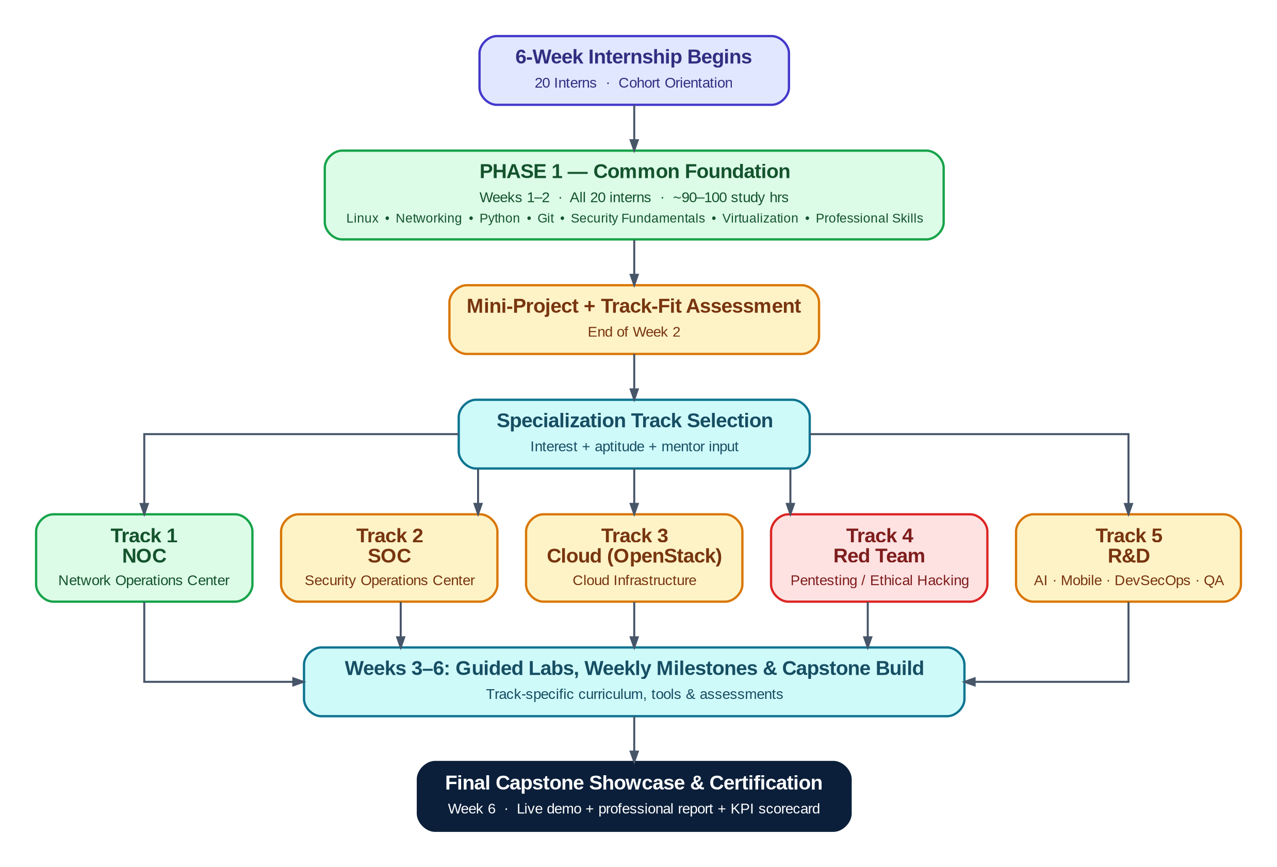
Figure 1 — End-to-end program flow: Common Foundation → Track Selection → Specialization → Capstone Showcase

1.2 The Two Phases

Phase 1 — Common Foundation (Weeks 1–2)
All 20 interns follow an identical curriculum covering Linux, networking, Python, Git, cybersecurity fundamentals, virtualization, and professional skills. This ensures every intern — regardless of specialization — shares a common technical baseline before splitting into tracks. Phase 1 ends with a graded mini-project and a track-fit conversation with mentors.

Phase 2 — Specialization (Weeks 3–6)
Interns split into five tracks aligned to real industry job families:
- Track 1 — NOC (Network Operations Center)
- Track 2 — SOC (Security Operations Center)
- Track 3 — Cloud (OpenStack-based private cloud engineering)
- Track 4 — Cybersecurity (Red Team / Penetration Testing)
- Track 5 — R&D (Research & Development — AI, Mobile, DevSecOps, or Automation)
Each track runs for 4 weeks with its own learning objectives, weekly milestones, hands-on labs, mini-projects, required tools, and a final capstone project mapped to specific job roles.

1.3 How to Read This Roadmap
Every topic node throughout this document follows the same format, so you can scan quickly: a coloured difficulty marker, a mandatory/optional badge, an estimated study-time budget, and (where relevant) a prerequisite. A worked example:
● INTERMEDIATE MANDATORY ~14h Prereq: Linux Fundamentals
Marker | Meaning
● Beginner | No prior experience assumed beyond general computer literacy.
● Intermediate | Builds directly on Beginner topics earlier in the same track or Phase 1.
● Advanced | Requires comfort with the Intermediate material that precedes it; expect a steeper learning curve.
MANDATORY | Required for every intern in that track to reach capstone readiness.
OPTIONAL | Stretch content for interns who finish core material early or want deeper specialization.
~Nh | Estimated self-study + lab hours to reach working competency (excludes live instruction).
Prereq: | Topic(s) that should be completed first; "None" means it can start immediately.
Note on resources: to keep this roadmap usable rather than overwhelming, resources are grouped at the topic-cluster level rather than one link per micro-topic. Every cluster lists official documentation first, then free courses, video walkthroughs, hands-on practice platforms, repositories, and — where useful — books or certifications.

2. Phase 1 — Common Foundation (Weeks 1–2)
All 20 interns complete this identical two-week curriculum before selecting a specialization track. Topics build progressively — operating systems and networking first, then programming and version control, then security fundamentals and virtualization — so that every concept has the prerequisite knowledge it needs already in place.

2.1 Learning Objectives
- Operate confidently in a Linux command-line environment, including permissions, processes, and basic Bash automation.
- Explain and apply core networking concepts (OSI/TCP-IP, DNS/DHCP, routing/switching, VPNs) and use Wireshark to inspect real traffic.
- Write Python scripts that automate real tasks and interact with REST APIs.
- Use Git/GitHub professionally: branches, pull requests, and code review collaboration.
- Explain the CIA triad, authentication vs. authorization, encryption, hashing, and PKI — and apply basic vulnerability-management practice.
- Provision and use virtual machines and Docker containers as disposable lab environments.
- Produce clear technical documentation and work inside a lightweight Agile/Scrum cadence.

2.2 Foundation Roadmap
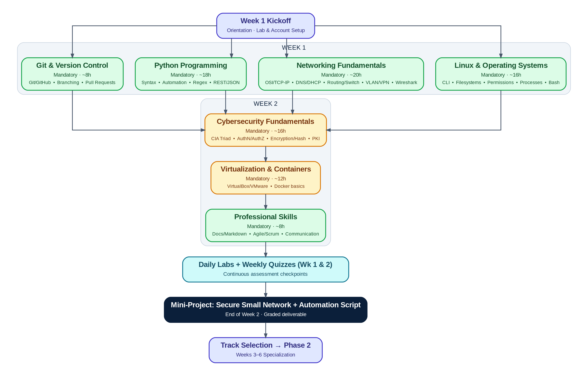
Figure 2 — Phase 1 topic flow across Week 1 and Week 2, converging on the Week 2 mini-project and track selection

2.3 Topic Breakdown

2.3.1 Operating Systems — Linux
● BEGINNER MANDATORY ~16h Prereq: None
The command line is the foundation every other Phase 1 topic (and every track) is built on.
Covers: Linux fundamentals • Linux command line • File systems • User & permission management • Process management • Bash scripting
Hands-on labs:

Resources:
- Official Docs: Ubuntu Documentation
- Free Course: Linux Foundation — Introduction to Linux (LFS101)
- Video / YouTube: freeCodeCamp — Linux Crash Course (with labs)
- Hands-on / Practice: OverTheWire: Bandit wargame
- Book (optional): The Linux Command Line (W. Shotts, free PDF)
- Certification (optional): CompTIA Linux+

2.3.2 Networking Fundamentals
● BEGINNER MANDATORY ~20h Prereq: Linux (helps, not required)
Covers the full stack from cabling to application-layer protocols, with Wireshark tying theory to real packets.
Covers: OSI Model • TCP/IP • IPv4 & IPv6 • DNS • DHCP • Routing • Switching • VLANs • VPNs • HTTP/HTTPS • SSH • SMTP • FTP • Firewalls • Wireshark
Hands-on labs:

Resources:
- Official Docs: Cisco Networking Academy — Skills for All
- Free Course: freeCodeCamp — How Computer Networks Work (9-hr, Network+ aligned)
- Video / YouTube: freeCodeCamp.org YouTube channel
- Hands-on / Practice: Wireshark Sample Captures library
- Certification (optional): CompTIA Network+

2.3.3 Programming — Python
● BEGINNER MANDATORY ~18h Prereq: None
Python is the automation language used across every track later in the program — this cluster gets everyone to a working baseline.
Covers: Python fundamentals • Python for automation • Regular expressions • APIs • JSON • REST
Hands-on labs:

Resources:
- Official Docs: Python Official Documentation
- Free Course: freeCodeCamp — Python Full Course for Beginners
- Video / YouTube: freeCodeCamp — Networking in Python (4 hands-on projects)
- Hands-on / Practice: Real Python tutorials
- Certification (optional): PCEP — Certified Entry-Level Python Programmer (Python Institute)

2.3.4 Version Control — Git & GitHub
● BEGINNER MANDATORY ~8h Prereq: None
Every deliverable from here forward — labs, mini-projects, capstones — is submitted through Git, so this cluster is scheduled early.
Covers: Git • GitHub • Branching • Pull Requests • Collaboration
Hands-on labs:

Resources:
- Official Docs: Git Official Documentation
- Free Course: GitHub Docs — Get Started
- Video / YouTube: freeCodeCamp.org YouTube — search "Git and GitHub for Beginners"
- Hands-on / Practice: GitHub Skills (interactive courses)
- Repository: first-contributions (beginner PR practice repo)

2.3.5 Cybersecurity Fundamentals
● INTERMEDIATE MANDATORY ~16h Prereq: Networking Fundamentals
The shared security vocabulary and mental model every track — NOC, SOC, Cloud, Red Team, R&D — builds on.
Covers: CIA Triad • Authentication • Authorization • Encryption • Hashing • PKI • Vulnerability Management • Security Best Practices
Hands-on labs:

Resources:
- Official Docs: NIST Cybersecurity Framework (CSF 2.0)
- Free Course: Cisco — Introduction to Cybersecurity (Skills for All)
- Video / YouTube: freeCodeCamp.org YouTube — search "Cyber Security Full Course"
- Hands-on / Practice: TryHackMe — "Pre Security" learning path
- Certification (optional): CompTIA Security+

2.3.6 Virtualization & Containers
● INTERMEDIATE MANDATORY ~12h Prereq: Linux
Every lab from Week 2 onward runs inside a VM or container, so interns need to be comfortable standing environments up and tearing them down.
Covers: VirtualBox • VMware • Docker fundamentals
Hands-on labs:

Resources:
- Official Docs: Docker Official Documentation
- Free Course: Docker — Get Started Guide
- Video / YouTube: freeCodeCamp.org YouTube — search "Docker Tutorial for Beginners"
- Hands-on / Practice: Play with Docker (browser-based sandbox)

2.3.7 Professional Skills
● BEGINNER MANDATORY ~8h Prereq: None
Technical skill without communication skill doesn't ship — this cluster is graded as part of every later deliverable, not just Phase 1.
Covers: Documentation • Technical writing • Markdown • Agile • Scrum • Communication • Presentation skills
Hands-on labs:

Resources:
- Official Docs: Markdown Guide
- Free Course: Atlassian Agile Coach — Agile & Scrum 101
- Video / YouTube: freeCodeCamp.org YouTube — search "Technical Writing"

2.4 Week 1 Daily Schedule
Day | Morning Focus | Afternoon Focus | Daily Lab / Deliverable
Mon | Orientation, account & lab-environment setup, cohort introductions | Linux basics: shell navigation, filesystem hierarchy | Document a Linux filesystem walkthrough (CLI-only)
Tue | Linux permissions & ownership | Process management + intro Bash scripting | Bash script: bulk-fix a broken permission tree
Wed | Networking: OSI model, TCP/IP, IPv4/IPv6 | DNS, DHCP, routing & switching basics | Wireshark capture: identify 6+ protocols
Thu | VLANs, VPNs, firewalls, HTTP/HTTPS, SSH | Python fundamentals begin | Packet Tracer: build a mini routed/switched topology
Fri | Python for automation & regular expressions | Git & GitHub setup, first branch + pull request | Weekly Quiz 1 + automation script submitted via PR

2.5 Week 2 Daily Schedule
Day | Morning Focus | Afternoon Focus | Daily Lab / Deliverable
Mon | APIs, REST & JSON in Python | Cybersecurity fundamentals: CIA triad, authN/authZ | Script: consume a public REST API end-to-end
Tue | Encryption, hashing, PKI | Vulnerability management & security best practices | Hash-verification exercise + guided vulnerability scan
Wed | Virtualization: VirtualBox / VMware | Docker fundamentals | Provision 2 VMs + containerize a script
Thu | Professional skills: documentation, Markdown, Agile/Scrum | Mini-project build session (mentor office hours) | README + sprint board set up for mini-project
Fri | Mini-project completion & rehearsal | Mini-project demo day + track-fit conversations | Weekly Quiz 2 + Mini-Project live demo

2.6 Weekly Assessment Checkpoints
Checkpoint | Covers | Format | Weight toward Foundation KPI
Daily Labs (10 total) | That day's topic cluster | Graded pass/revise checklist, submitted via Git | 40%
Weekly Quiz 1 (Fri, Wk 1) | Linux, Networking, Python basics, Git | 20 MCQ/short-answer, 30 minutes | 15%
Weekly Quiz 2 (Fri, Wk 2) | Security fundamentals, virtualization, professional skills | 20 MCQ/short-answer, 30 minutes | 15%
Mini-Project (end of Wk 2) | Integrates all 7 clusters | Working deliverable + live demo + README | 30%
Full scoring rubrics and the printable Weekly KPI Scorecard used to record these checkpoints are provided in Section 9 — Intern KPI & Evaluation Templates.

2.7 Mini-Project — End of Week 2

"Secure Small Network + Automation Toolkit"
Working in pairs, interns design and document a small routed/switched lab network (Packet Tracer or GNS3), harden one Linux host on it (SSH hardening, firewall rules, least-privilege users), and write a Python automation script that checks the host's security posture (e.g., verifies firewall rules, flags weak permissions, or polls a REST API health check). The deliverable is submitted as a GitHub repository with a full README, and presented as a 5-minute live demo to mentors.
Required deliverables: (1) network topology diagram, (2) hardened VM with documented configuration, (3) working Python automation script with tests, (4) README.md, (5) 5-minute live demo.
Evaluation: scored against the Mini-Project Evaluation Rubric in Section 9.4, and feeds directly into each intern's track-fit conversation with mentors.

3. Phase 2 — Specialization Overview (Weeks 3–6)
At the start of Week 3, interns move from the shared Phase 1 curriculum into one of five specialization tracks. Track assignment is a three-way conversation between intern interest, demonstrated aptitude (from Phase 1 labs, quizzes, and the mini-project), and mentor guidance — not a purely first-come-first-served pick.

3.1 How Track Selection Works
- Interns rank their top 2 track preferences after the Week 2 mini-project demo.
- Mentors review each intern's Phase 1 KPI scorecard (Section 9.2) alongside stated preference.
- Where demand exceeds a track's cohort capacity, aptitude signals (relevant lab scores, quiz performance) break ties.
- Track 5 (R&D) additionally requires choosing a domain (or domains) within the first two days of Week 3 — see Section 8.
- Assignments are communicated by the Monday of Week 3 so every intern starts specialization content on time.

3.2 Track Comparison
Track | Focus | Est. Hours | Primary Job Roles
1 — NOC | Enterprise network design, operations & monitoring | ~110–120h | NOC Technician/Analyst, Network Ops Engineer
2 — SOC | Detection, investigation & incident response | ~110–120h | SOC Analyst (L1/L2), Threat Detection Analyst
3 — Cloud (OpenStack) | Private cloud deployment & automation | ~115–125h | Cloud/OpenStack Engineer, Cloud Infrastructure Associate
4 — Red Team | Offensive security & penetration testing | ~120–130h | Junior Penetration Tester, Red Team Associate
5 — R&D | AI, Mobile, DevSecOps, or Automation prototyping | ~110–120h | Junior AI/ML Engineer, Mobile Developer, DevSecOps Engineer
Detailed learning objectives, weekly milestones, tools, resources, and capstones for each track follow in Sections 4–8.

4. Track 1 — NOC (Network Operations Center)
Keep enterprise networks designed, deployed, monitored, and fast to troubleshoot — the backbone role every other track depends on.
Field | Detail
Duration | 4 weeks (Weeks 3–6)
Prerequisites | Phase 1 complete — especially Networking Fundamentals and Linux
Estimated Study Hours | ~110–120 hours across 4 weeks
Target Job Roles | NOC Technician / Analyst · Network Operations Engineer · Junior Network Administrator · Network Support Engineer

4.1 Learning Objectives
- Configure and troubleshoot enterprise switching (VLANs, trunking, STP) and routing (static + OSPF) on real Cisco IOS devices or simulators.
- Implement access control (ACLs) and address translation (NAT/PAT) to secure and scale a network.
- Stand up a site-to-site VPN and a zone-based firewall policy.
- Deploy DNS/DHCP services and explain their role in enterprise operations.
- Build a monitoring stack (SNMP + Syslog + dashboards) that surfaces outages before users report them.
- Apply a structured troubleshooting methodology to diagnose and resolve multi-layer network faults.

4.2 Required Tools
Tool | Purpose
Cisco Packet Tracer | Primary simulator for device configuration and topology labs
GNS3 | Advanced/near-production network emulation for capstone-level topologies
Wireshark | Packet capture and protocol-level troubleshooting
Zabbix | Infrastructure monitoring, alerting, and SLA dashboards
Grafana | Visualization layer for monitoring metrics
LibreNMS | Auto-discovery network monitoring (SNMP-based)

4.3 Track Roadmap
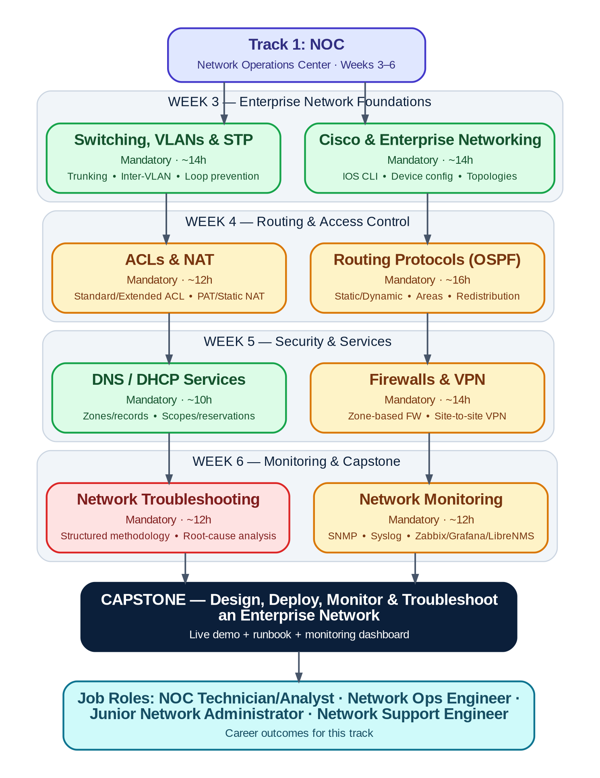
Figure 3 — NOC track roadmap: Weeks 3–6 progressing from Cisco fundamentals to enterprise capstone

4.4 Topic Breakdown

4.4.1 Cisco & Enterprise Networking
● BEGINNER MANDATORY ~14h Prereq: Phase 1 Networking Fundamentals
Translates OSI/TCP-IP theory into real Cisco IOS command-line practice on switches and routers.
Covers: Enterprise networking concepts • Cisco IOS CLI • Device configuration • Topology design
Hands-on labs:

Resources:
- Official Docs: Cisco CCNA Certification Overview
- Free Course: Cisco Networking Academy — Skills for All
- Hands-on / Practice: GNS3 network simulator
- Certification (optional): Cisco CCNA (200-301)

4.4.2 Switching, VLANs & STP
● BEGINNER MANDATORY ~14h Prereq: Cisco & Enterprise Networking
Segmentation and loop-prevention — the two things that make switched networks scale safely.
Covers: Switching • VLANs • Trunking (802.1Q) • Inter-VLAN routing • Spanning Tree Protocol (STP)
Hands-on labs:

Resources:
- Official Docs: Cisco Networking Academy — Learning Catalog
- Free Course: CCNA: Introduction to Networks (free course)
- Hands-on / Practice: Cisco Packet Tracer labs (via Skills for All)

4.4.3 Routing Protocols (OSPF)
● INTERMEDIATE MANDATORY ~16h Prereq: Switching, VLANs & STP
Dynamic routing is what lets a network grow without every route being typed in by hand.
Covers: Static vs. dynamic routing • OSPF single-area • OSPF multi-area • Route redistribution basics
Hands-on labs:

Resources:
- Official Docs: Cisco Networking Academy — Skills for All
- Hands-on / Practice: GNS3 network simulator
- Certification (optional): Cisco CCNA (200-301)

4.4.4 ACLs & NAT
● INTERMEDIATE MANDATORY ~12h Prereq: Routing Protocols (OSPF)
The first line of traffic control on most enterprise edges — simple rules, high blast radius if misconfigured.
Covers: Standard ACLs • Extended ACLs • Static NAT • PAT (NAT overload)
Hands-on labs:

Resources:
- Official Docs: Cisco Networking Academy — Skills for All
- Hands-on / Practice: Cisco Packet Tracer labs

4.4.5 Firewalls & VPN
● INTERMEDIATE MANDATORY ~14h Prereq: ACLs & NAT
Moves from basic packet filtering to policy-based security and secure site-to-site connectivity.
Covers: Zone-based firewall policy • Site-to-site VPN • IPsec basics
Hands-on labs:

Resources:
- Official Docs: Cisco Networking Academy — Skills for All
- Video / YouTube: freeCodeCamp.org YouTube — search "VPN and firewall fundamentals"

4.4.6 DNS / DHCP Services
● BEGINNER MANDATORY ~10h Prereq: Phase 1 Networking Fundamentals
The two services that, when they fail, generate the most NOC tickets — worth mastering deeply.
Covers: DNS zones & records • DHCP scopes & reservations • Troubleshooting resolution failures
Hands-on labs:

Resources:
- Official Docs: Cisco Networking Academy — Skills for All
- Hands-on / Practice: GNS3 network simulator

4.4.7 Network Monitoring
● INTERMEDIATE MANDATORY ~12h Prereq: Firewalls & VPN, DNS/DHCP Services
Turns a NOC from reactive to proactive — the difference between finding out from a user and finding out from a dashboard.
Covers: SNMP • Syslog • Zabbix • Grafana • LibreNMS
Hands-on labs:

Resources:
- Official Docs: Zabbix Documentation
- Free Course: Grafana Documentation
- Hands-on / Practice: LibreNMS Documentation

4.4.8 Network Troubleshooting
● ADVANCED MANDATORY ~12h Prereq: Network Monitoring
Integrates everything above into a repeatable diagnostic methodology instead of guesswork.
Covers: Structured troubleshooting methodology (OSI-layer approach) • Root-cause analysis • Documentation under pressure
Hands-on labs:

Resources:
- Official Docs: Wireshark Documentation
- Hands-on / Practice: Wireshark Sample Captures library

4.5 Weekly Milestones
Week | Focus & Objective | Key Deliverable | Checkpoint
Wk 3 | Cisco fundamentals, switching, VLANs & STP mastered on real device CLI | 3-tier topology built + documented in Packet Tracer | Lab review + quiz
Wk 4 | Dynamic routing (OSPF), ACLs, and NAT operational across multi-router topology | Mini-Project 1: Segmented, access-controlled network | Mini-project demo
Wk 5 | Firewalls, VPN, and DNS/DHCP services deployed and hardened | Mini-Project 2: Secure branch-to-HQ connectivity | Mini-project demo + peer review
Wk 6 | Monitoring stack live; troubleshooting methodology applied under injected-fault scenarios | Capstone: full enterprise network build | Capstone showcase

4.6 Sample Daily Activities
Representative week (Week 4) — the same daily rhythm (concept → guided lab → independent practice) repeats each week with new topics.
Day | Concept Block (AM) | Guided Lab (PM) | Independent Practice / Output
Mon | OSPF theory: areas, metrics, DR/BDR election | Configure single-area OSPF across 3 routers | Document routing table + explain convergence
Tue | OSPF troubleshooting patterns | Break a link; observe & explain reconvergence | Write a one-page incident note
Wed | ACL theory: standard vs. extended | Write & apply an extended ACL between VLANs | Test & document permitted/denied traffic
Thu | NAT/PAT theory | Configure PAT for outbound internet access | Verify translation table + peer walkthrough
Fri | Week 4 review + mentor office hours | Mini-Project 1 build & polish | Mini-Project 1 live demo + weekly quiz

4.7 Mini-Projects

Mini-Project 1: Segmented, Access-Controlled Network (end of Week 4)
Design a 3-VLAN network (Staff / Guest / Servers) with inter-VLAN routing, an extended ACL policy enforcing least-privilege access between segments, and PAT for shared internet egress.
Deliverable: Packet Tracer topology file + configuration exports + a one-page network diagram with ACL logic explained.

Mini-Project 2: Secure Branch-to-HQ Connectivity (end of Week 5)
Extend the Week 4 network with a simulated branch site connected via site-to-site VPN, protected by a zone-based firewall policy, with working DNS and DHCP services for both sites.
Deliverable: Updated topology + VPN/firewall configs + DNS/DHCP verification screenshots + short write-up.

4.8 Assessment Checkpoints
Checkpoint | Covers | Format | Weight
Weekly Labs (4 sets) | That week's cluster topics | Config export + verification screenshots, reviewed by mentor | 35%
Weekly Quiz (×4) | Concepts from that week | 20 MCQ/short-answer, 30 min | 15%
Mini-Project 1 & 2 | Weeks 4–5 integrated skills | Working topology + live walkthrough | 25%
Capstone | Full track | Live demo + runbook + monitoring dashboard | 25%

4.9 Capstone Project

Design, Deploy, Monitor & Troubleshoot an Enterprise Network
Acting as the NOC team for a fictional mid-size company opening a new branch office, interns (in pairs) design a 2-site enterprise network from scratch: HQ and branch, each multi-VLAN, connected via site-to-site VPN, protected by ACLs and a firewall policy, running DHCP/DNS, and fully monitored.
Requirements:
- Minimum 2 sites, 3+ VLANs per site, OSPF routing between all routed segments.
- Working site-to-site VPN and a documented firewall policy.
- DHCP and DNS services operational at both sites.
- Zabbix or LibreNMS + Grafana dashboard monitoring all devices with alert thresholds configured.
- A written runbook covering at least 3 common failure scenarios and their resolution steps.
Deliverables:
- Complete topology file (Packet Tracer or GNS3) with all configurations.
- Network diagram (logical + physical).
- Live monitoring dashboard.
- Runbook document.
- 15-minute live demo including one "mentor-injected fault" diagnosed live.
Evaluation: Scored against the Capstone Evaluation Rubric in Section 9.5 across design quality, security posture, monitoring completeness, troubleshooting performance, and documentation.

4.10 Career Outcomes
This track prepares interns for entry-level roles such as: NOC Technician / Analyst · Network Operations Engineer · Junior Network Administrator · Network Support Engineer

5. Track 2 — SOC (Security Operations Center)
Detect, investigate, and respond to attacks before they become breaches — the defensive front line of cybersecurity.
Field | Detail
Duration | 4 weeks (Weeks 3–6)
Prerequisites | Phase 1 complete — especially Cybersecurity Fundamentals and Networking
Estimated Study Hours | ~110–120 hours across 4 weeks
Target Job Roles | SOC Analyst (L1/L2) · Security Analyst · Threat Detection Analyst · Incident Response Associate

5.1 Learning Objectives
- Operate a SIEM (Wazuh / ELK / Splunk) to search, correlate, and triage security events.
- Map observed attacker behavior to MITRE ATT&CK tactics and techniques.
- Write and tune Sigma detection rules against real log sources.
- Run the incident-response lifecycle end to end: detect, contain, eradicate, recover, document.
- Triage indicators of compromise (IOCs) and perform first-pass malware analysis safely.
- Use endpoint telemetry (Sysmon, Velociraptor) and threat intelligence (VirusTotal) to enrich investigations.

5.2 Required Tools
Tool | Purpose
Wazuh | Open-source SIEM/XDR — log collection, detection rules, dashboards
ELK Stack | Log ingestion, search, and visualization (Elasticsearch, Logstash, Kibana)
Splunk | Enterprise SIEM — search processing language (SPL) practice
Microsoft Sentinel | Cloud-native SIEM/SOAR exposure
Velociraptor | Endpoint DFIR — forensic artifact collection at scale
VirusTotal | File/URL/IOC reputation and threat intelligence lookups
Sysmon | Windows endpoint telemetry for detection engineering

5.3 Track Roadmap
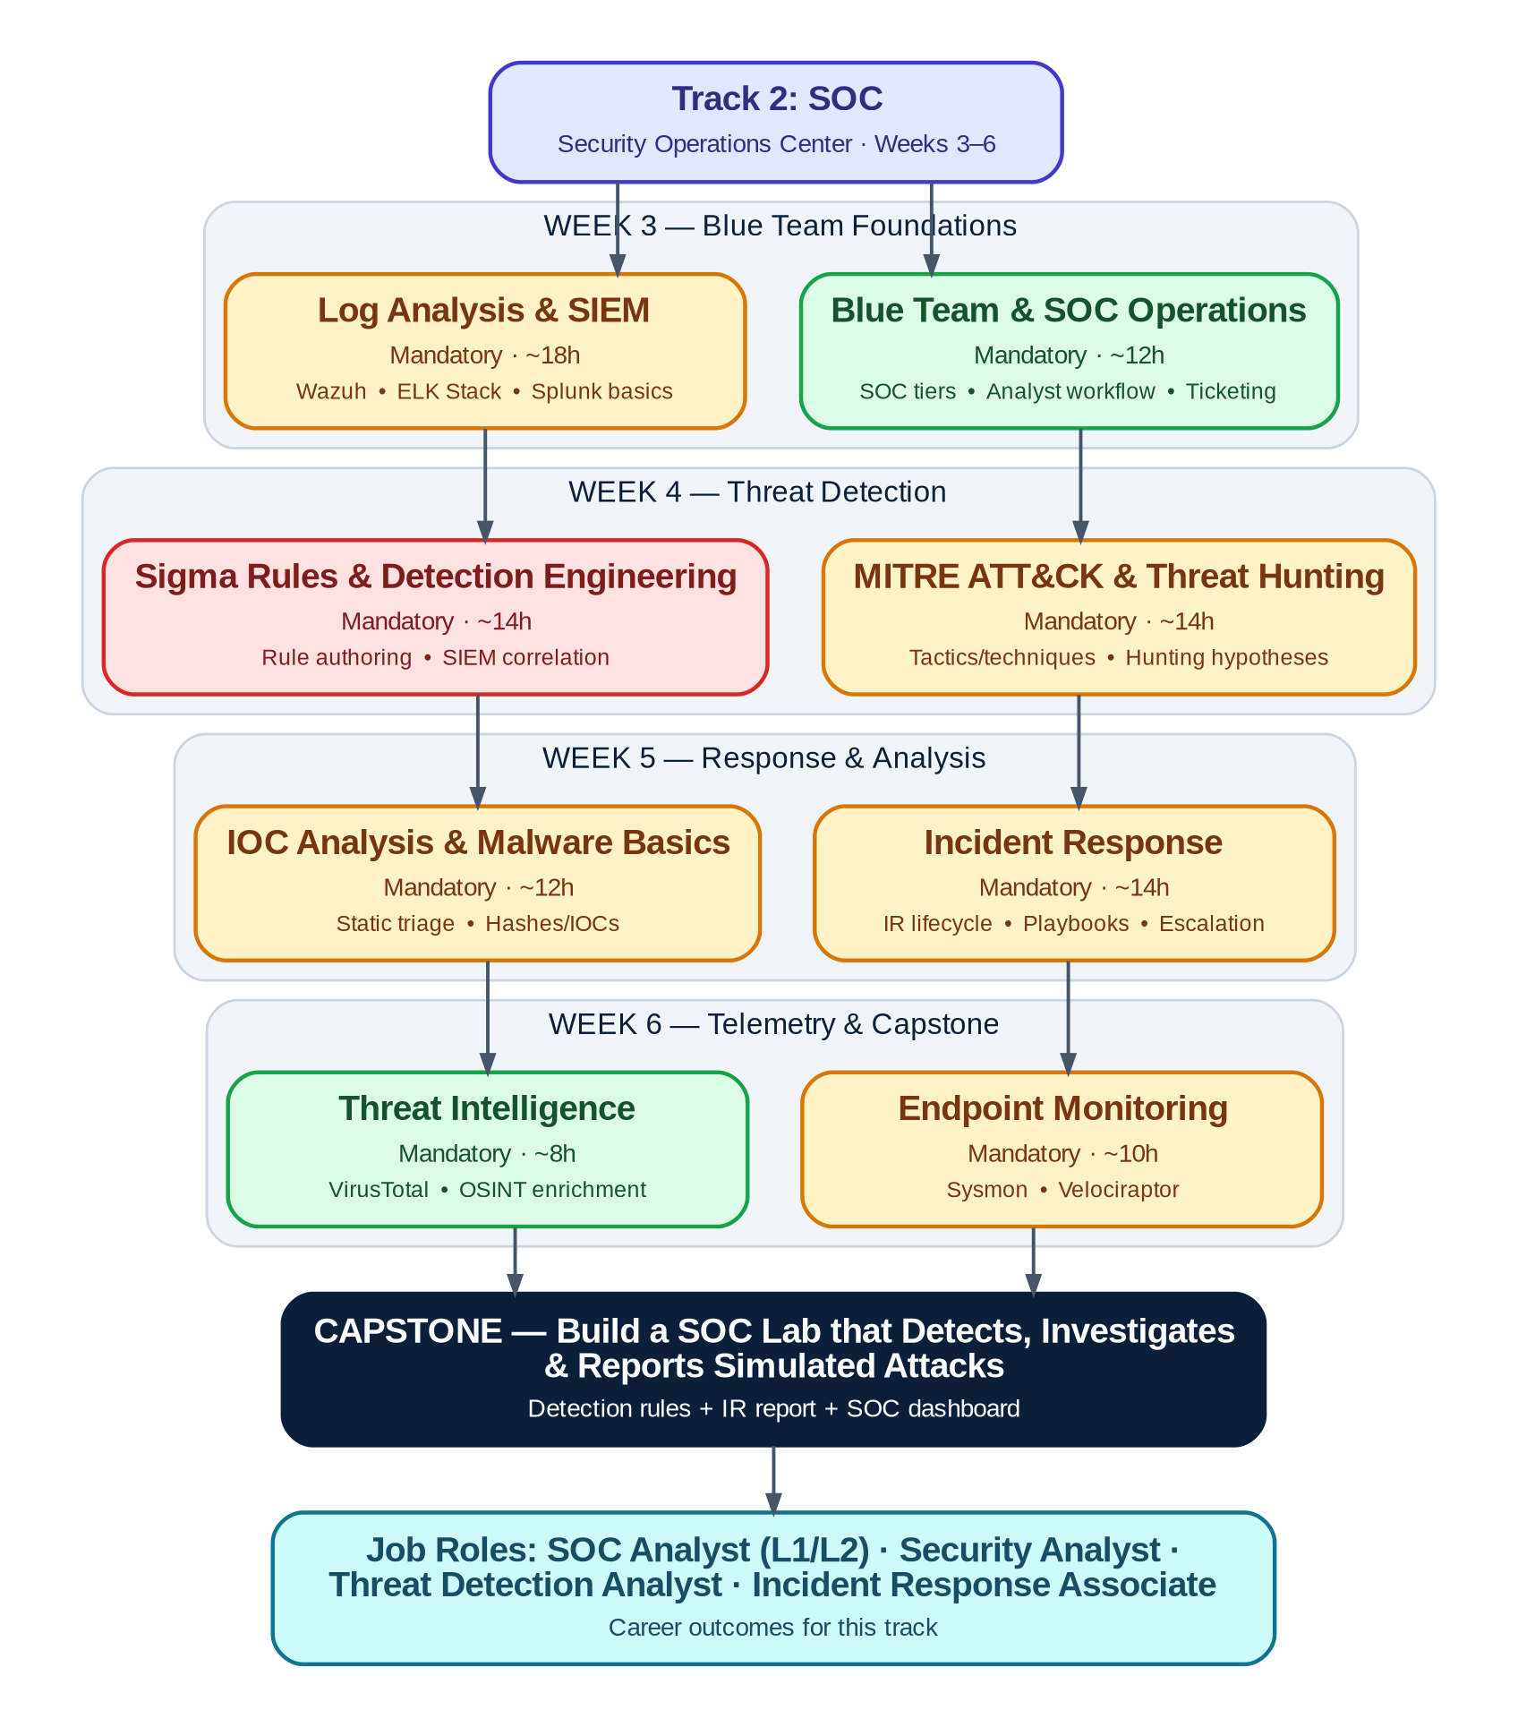
Figure 4 — SOC track roadmap: Weeks 3–6 progressing from Blue Team foundations to a live detection capstone

5.4 Topic Breakdown

5.4.1 Blue Team & SOC Operations
● BEGINNER MANDATORY ~12h Prereq: Phase 1 Cybersecurity Fundamentals
How a real SOC is organized — tiers, shift handoffs, ticketing — before touching any tooling.
Covers: SOC tiers (L1/L2/L3) • Analyst workflow • Ticketing & escalation
Hands-on labs:

Resources:
- Official Docs: TryHackMe — SOC Level 1 learning path
- Hands-on / Practice: LetsDefend — SOC analyst simulation platform

5.4.2 Log Analysis & SIEM
● INTERMEDIATE MANDATORY ~18h Prereq: Blue Team & SOC Operations
The daily-driver skill of a SOC analyst: pulling signal out of an overwhelming volume of logs.
Covers: Wazuh • ELK Stack (Elasticsearch/Logstash/Kibana) • Splunk SPL basics
Hands-on labs:

Resources:
- Official Docs: Wazuh Documentation
- Free Course: Elastic (ELK) Documentation
- Hands-on / Practice: Splunk Documentation

5.4.3 MITRE ATT&CK & Threat Hunting
● INTERMEDIATE MANDATORY ~14h Prereq: Log Analysis & SIEM
Gives analysts a shared vocabulary for adversary behavior and a starting point for proactive hunts.
Covers: Tactics & techniques • Sub-techniques • Building a hunting hypothesis
Hands-on labs:

Resources:
- Official Docs: MITRE ATT&CK — Enterprise Matrix
- Hands-on / Practice: MITRE ATT&CK Navigator

5.4.4 Sigma Rules & Detection Engineering
● ADVANCED MANDATORY ~14h Prereq: MITRE ATT&CK & Threat Hunting
Moves interns from consuming detections to writing and tuning their own — the SOC L2 skill.
Covers: Sigma rule syntax • Rule authoring • SIEM correlation & tuning false positives
Hands-on labs:

Resources:
- Official Docs: SigmaHQ — Main Rule Repository
- Free Course: Sigma — Resources & Getting Started

5.4.5 Incident Response
● INTERMEDIATE MANDATORY ~14h Prereq: Sigma Rules & Detection Engineering
The structured process that turns a detected alert into a closed, documented incident.
Covers: IR lifecycle (prepare, detect, contain, eradicate, recover, learn) • Playbooks • Escalation criteria
Hands-on labs:

Resources:
- Official Docs: NIST — Incident Handling Guidance (SP 800-61)
- Hands-on / Practice: TryHackMe — SOC Level 1 learning path

5.4.6 IOC Analysis & Malware Basics
● INTERMEDIATE MANDATORY ~12h Prereq: Incident Response
First-pass triage skills for suspicious files and indicators — enough to decide escalate vs. close.
Covers: Static triage • File hashes & IOCs • Safe-handling basics
Hands-on labs:

Resources:
- Official Docs: VirusTotal
- Hands-on / Practice: VirusTotal

5.4.7 Endpoint Monitoring
● INTERMEDIATE MANDATORY ~10h Prereq: IOC Analysis & Malware Basics
Extends visibility down to individual hosts, where most attacker activity actually happens.
Covers: Sysmon event logging • Velociraptor artifact collection
Hands-on labs:

Resources:
- Official Docs: Sysmon — Windows Sysinternals
- Repository: Velociraptor Documentation

5.4.8 Threat Intelligence
● BEGINNER MANDATORY ~8h Prereq: None
Enriches every investigation above with external context on who/what is behind an indicator.
Covers: VirusTotal enrichment • OSINT enrichment basics
Hands-on labs:

Resources:
- Official Docs: VirusTotal

5.5 Weekly Milestones
Week | Focus & Objective | Key Deliverable | Checkpoint
Wk 3 | SOC operations model understood; SIEM (Wazuh/ELK) deployed and queried | Working SIEM with onboarded log sources | Lab review + quiz
Wk 4 | ATT&CK mapping and Sigma rule authoring operational | Mini-Project 1: 5 custom detection rules | Mini-project demo
Wk 5 | Full IR lifecycle + malware/IOC triage practiced | Mini-Project 2: End-to-end incident report | Mini-project demo + peer review
Wk 6 | Endpoint telemetry and threat intel integrated into investigations | Capstone: SOC detection & investigation lab | Capstone showcase

5.6 Sample Daily Activities
Representative week (Week 4) — the same daily rhythm (concept → guided lab → independent practice) repeats each week with new topics.
Day | Concept Block (AM) | Guided Lab (PM) | Independent Practice / Output
Mon | ATT&CK tactics/techniques deep-dive | Map a sample attack narrative to ATT&CK | Navigator layer submitted for review
Tue | Threat-hunting hypothesis design | Hunt for T1059 across sample logs | Hunt findings write-up
Wed | Sigma rule syntax | Author a Sigma rule for a suspicious pattern | Rule converted & tested against SIEM
Thu | Detection tuning & false-positive reduction | Tune a noisy rule against sample data | Before/after FP-rate comparison
Fri | Week 4 review + mentor office hours | Mini-Project 1 build & polish | Mini-Project 1 live demo + weekly quiz

5.7 Mini-Projects

Mini-Project 1: Five Custom Detection Rules (end of Week 4)
Author 5 Sigma rules covering at least 3 different MITRE ATT&CK tactics, convert each to a working SIEM query, and validate each against sample or self-generated log data.
Deliverable: 5 Sigma rule files + SIEM query exports + a short validation write-up per rule (what it catches, why, tested false-positive rate).

Mini-Project 2: End-to-End Incident Report (end of Week 5)
Given a staged, multi-stage compromise in the lab environment, run the full IR lifecycle — detect via SIEM, contain, collect endpoint artifacts with Velociraptor, and produce a formal incident report.
Deliverable: Formal incident report (timeline, root cause, IOCs, remediation) + supporting SIEM/Velociraptor evidence exports.

5.8 Assessment Checkpoints
Checkpoint | Covers | Format | Weight
Weekly Labs (4 sets) | That week's cluster topics | Evidence export + mentor review | 35%
Weekly Quiz (×4) | Concepts from that week | 20 MCQ/short-answer, 30 min | 15%
Mini-Project 1 & 2 | Weeks 4–5 integrated skills | Deliverable + live walkthrough | 25%
Capstone | Full track | Live demo + detection rules + IR report | 25%

5.9 Capstone Project

Build a SOC Lab that Detects, Investigates & Reports Simulated Attacks
In pairs, interns stand up a mini-SOC (SIEM + endpoint telemetry + threat intel enrichment) monitoring a small lab network. A mentor (or automated attack simulation) then runs a multi-stage attack against the environment without prior warning, and interns must detect, investigate, and report it live.
Requirements:
- Working SIEM (Wazuh, ELK, or Splunk) ingesting logs from at least 3 sources.
- Minimum 8 custom detection rules (Sigma or native SIEM) mapped to ATT&CK.
- Sysmon deployed on at least one monitored endpoint.
- A documented incident-response playbook used during the live exercise.
- A professional incident report produced within 24 hours of the simulated attack.
Deliverables:
- SOC dashboard (live).
- Detection rule set with ATT&CK mapping.
- Incident-response playbook.
- Final incident report.
- 15-minute live demo replaying the detection-to-report timeline.
Evaluation: Scored against the Capstone Evaluation Rubric in Section 9.5 across detection coverage, investigation quality, response time, and report clarity.

5.10 Career Outcomes
This track prepares interns for entry-level roles such as: SOC Analyst (L1/L2) · Security Analyst · Threat Detection Analyst · Incident Response Associate

6. Track 3 — Cloud (OpenStack)
Deploy, operate, and automate a real private cloud on OpenStack — this specialization is 100% OpenStack, not AWS/Azure/GCP.
Field | Detail
Duration | 4 weeks (Weeks 3–6)
Prerequisites | Phase 1 complete — especially Linux, Virtualization & Containers, and Networking Fundamentals
Estimated Study Hours | ~115–125 hours across 4 weeks
Target Job Roles | Cloud / OpenStack Engineer · Cloud Infrastructure Associate · DevOps Engineer (Cloud) · Cloud Support Engineer

6.1 Learning Objectives
- Explain core cloud computing models (IaaS/PaaS/SaaS) and how OpenStack implements IaaS.
- Deploy OpenStack via both DevStack (single-node, dev) and Kolla-Ansible (containerized, production-style).
- Operate the core services — Keystone, Nova, Neutron, Glance, Cinder, Swift — from CLI, API, and Horizon.
- Configure tenant networking: provider/self-service networks, security groups, and floating IPs.
- Automate provisioning with Terraform and Ansible against the OpenStack API.
- Design for high availability across a multi-node deployment and monitor cloud health with Prometheus/Grafana.

6.2 Required Tools
Tool | Purpose
DevStack | Fast single-node OpenStack install for learning and development
Kolla-Ansible | Containerized, production-style multi-node OpenStack deployment
OpenStack CLI | Command-line control of every OpenStack service
Terraform | Infrastructure-as-Code provisioning against the OpenStack provider
Ansible | Configuration management and OpenStack automation
Prometheus | Metrics collection for cloud infrastructure health
Grafana | Dashboards and alerting on top of Prometheus

6.3 Track Roadmap
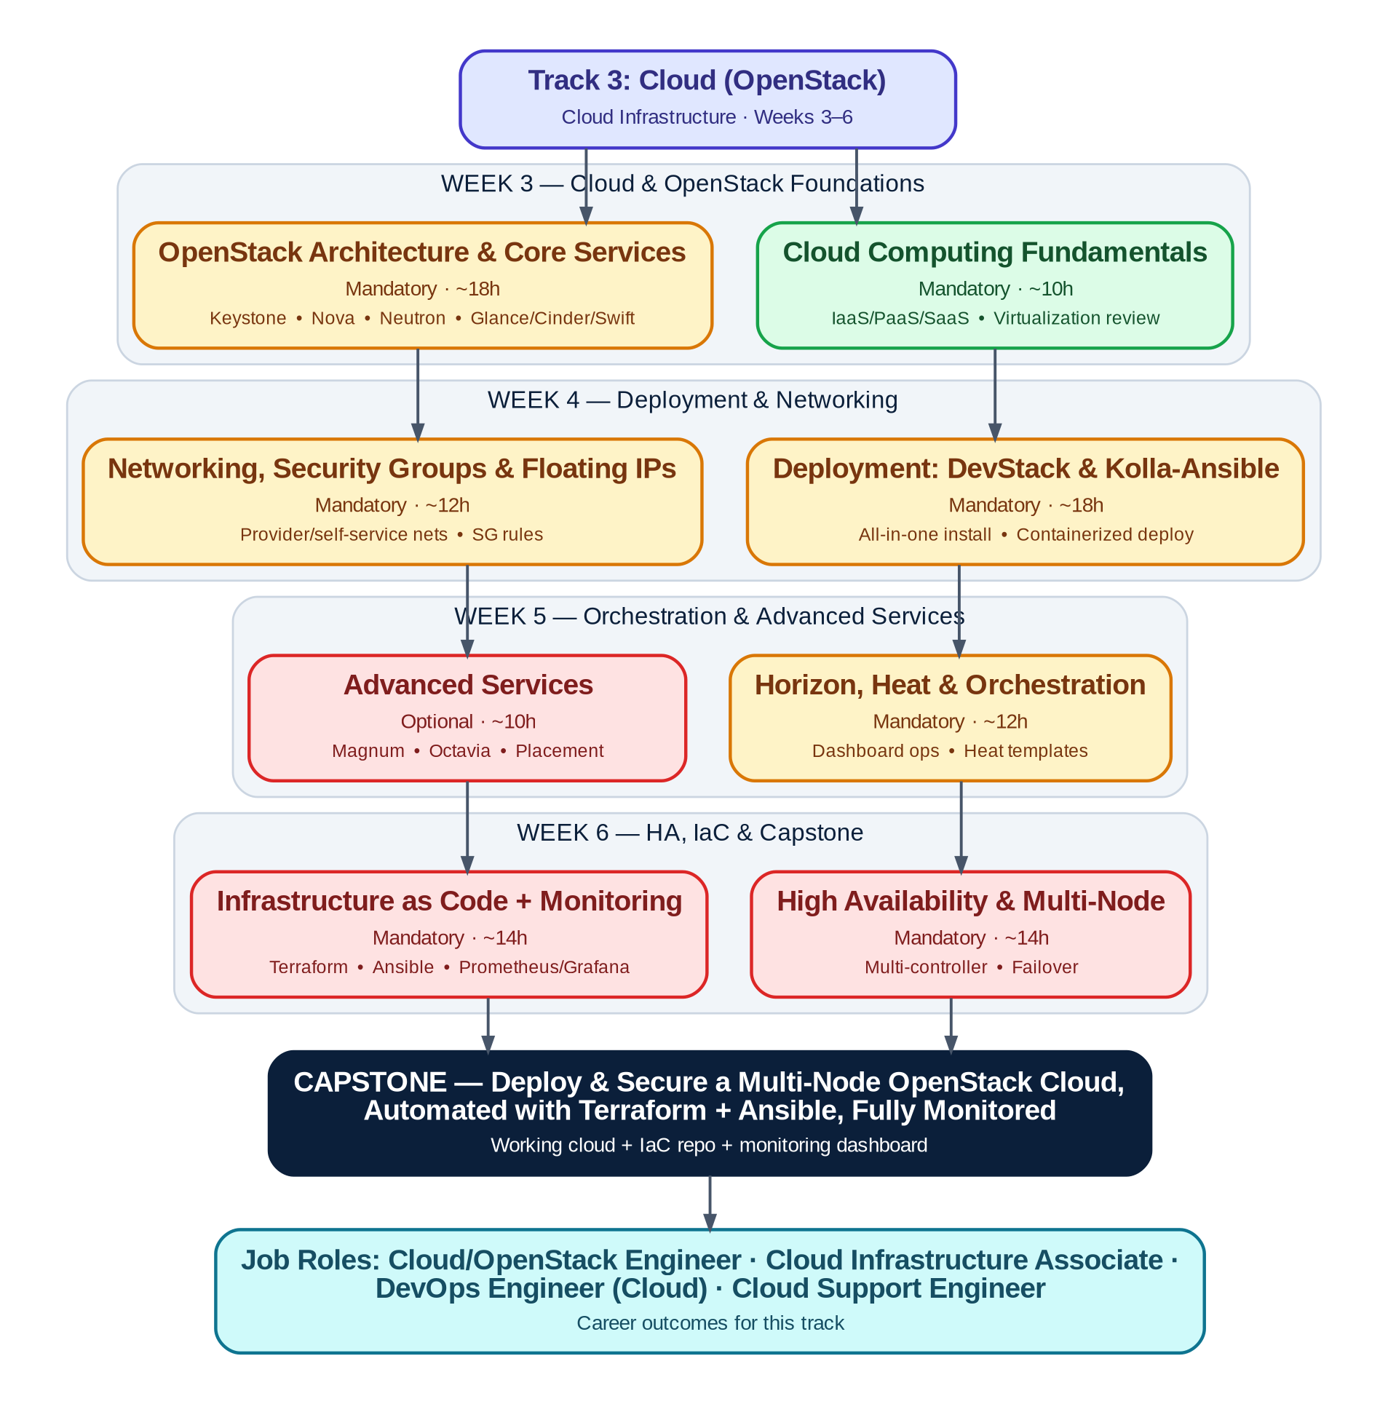
Figure 5 — Cloud (OpenStack) track roadmap: Weeks 3–6 from cloud fundamentals to a production-style multi-node capstone

6.4 Topic Breakdown

6.4.1 Cloud Computing Fundamentals
● BEGINNER MANDATORY ~10h Prereq: Phase 1 Virtualization & Containers
The vocabulary and service models every cloud engineer needs before touching OpenStack itself.
Covers: IaaS / PaaS / SaaS • Public / private / hybrid cloud • Virtualization review
Hands-on labs:

Resources:
- Official Docs: OpenStack Documentation home
- Free Course: roadmap.sh — DevOps roadmap (cloud fundamentals section)

6.4.2 OpenStack Architecture & Core Services
● INTERMEDIATE MANDATORY ~18h Prereq: Cloud Computing Fundamentals
The services that make up 'OpenStack' — identity, compute, network, image, and storage — and how they talk to each other.
Covers: Keystone (identity) • Nova (compute) • Neutron (network) • Glance (image) • Cinder (block storage) • Swift (object storage)
Hands-on labs:

Resources:
- Official Docs: OpenStack Documentation home
- Free Course: OpenStack Install Guide
- Hands-on / Practice: OpenStack Client (CLI) Documentation

6.4.3 Deployment: DevStack & Kolla-Ansible
● INTERMEDIATE MANDATORY ~18h Prereq: OpenStack Architecture & Core Services
Two deployment philosophies: DevStack for fast iteration, Kolla-Ansible for something closer to production.
Covers: DevStack all-in-one install • Kolla-Ansible containerized deploy • globals.yml configuration
Hands-on labs:

Resources:
- Official Docs: DevStack Documentation
- Free Course: Kolla Ansible Documentation
- Repository: openstack/kolla-ansible (GitHub)

6.4.4 Networking, Security Groups & Floating IPs
● INTERMEDIATE MANDATORY ~12h Prereq: Deployment: DevStack & Kolla-Ansible
Tenant networking is where most real-world OpenStack troubleshooting time goes — worth its own dedicated cluster.
Covers: Provider vs. self-service networks • Security group rules • Floating IP allocation & association
Hands-on labs:

Resources:
- Official Docs: OpenStack Networking Guide
- Hands-on / Practice: OpenStack Client (CLI) Documentation

6.4.5 Horizon, Heat & Orchestration
● INTERMEDIATE MANDATORY ~12h Prereq: Networking, Security Groups & Floating IPs
The dashboard operators actually click through daily, plus template-driven orchestration for repeatable stacks.
Covers: Horizon dashboard operations • Heat Orchestration Templates (HOT)
Hands-on labs:

Resources:
- Official Docs: OpenStack Documentation home

6.4.6 Advanced Services
● ADVANCED OPTIONAL ~10h Prereq: Horizon, Heat & Orchestration
Optional deep cuts for interns who want exposure to container-on-OpenStack and load-balancing services.
Covers: Magnum (container orchestration) • Octavia (load balancing as a service) • Placement (resource scheduling)
Hands-on labs:

Resources:
- Official Docs: OpenStack Documentation home

6.4.7 High Availability & Multi-Node
● ADVANCED MANDATORY ~14h Prereq: Deployment: DevStack & Kolla-Ansible
Single-node clouds don't survive a reboot gracefully — this is where the deployment becomes genuinely production-minded.
Covers: Multi-controller design • Failover behavior • Backup basics
Hands-on labs:

Resources:
- Official Docs: Kolla Ansible Documentation

6.4.8 Infrastructure as Code + Monitoring
● ADVANCED MANDATORY ~14h Prereq: High Availability & Multi-Node
Ties the whole track together: nothing gets clicked by hand, and everything is observable.
Covers: Terraform (OpenStack provider) • Ansible for OpenStack • Prometheus + Grafana monitoring
Hands-on labs:

Resources:
- Official Docs: HashiCorp Terraform Documentation
- Free Course: Terraform OpenStack Provider Docs
- Hands-on / Practice: Ansible Documentation
- Repository: Prometheus Documentation

6.5 Weekly Milestones
Week | Focus & Objective | Key Deliverable | Checkpoint
Wk 3 | Cloud fundamentals understood; OpenStack architecture mapped and a single-node cloud running via DevStack | Working DevStack all-in-one deployment | Lab review + quiz
Wk 4 | Kolla-Ansible deployment and tenant networking operational | Mini-Project 1: Networked, access-controlled DevStack tenant | Mini-project demo
Wk 5 | Horizon/Heat orchestration and multi-node HA design practiced | Mini-Project 2: Heat-templated stack on a multi-node cloud | Mini-project demo + peer review
Wk 6 | IaC (Terraform/Ansible) and monitoring layered on top of the cloud | Capstone: production-style multi-node OpenStack cloud | Capstone showcase

6.6 Sample Daily Activities
Representative week (Week 4) — the same daily rhythm (concept → guided lab → independent practice) repeats each week with new topics.
Day | Concept Block (AM) | Guided Lab (PM) | Independent Practice / Output
Mon | Kolla-Ansible architecture & globals.yml | Deploy Kolla-Ansible all-in-one | Compare operational experience vs. DevStack (write-up)
Tue | Kolla-Ansible service selection | Enable an additional service (e.g., Cinder) and redeploy | Verify new service via CLI
Wed | Tenant networking deep-dive | Build an isolated network + router + floating IP | Verify external connectivity to instance
Thu | Security groups & least privilege | Write and apply restrictive security group rules | Port-scan verification + write-up
Fri | Week 4 review + mentor office hours | Mini-Project 1 build & polish | Mini-Project 1 live demo + weekly quiz

6.7 Mini-Projects

Mini-Project 1: Networked, Access-Controlled Tenant (end of Week 4)
On your Kolla-Ansible or DevStack cloud, build a tenant environment with an isolated network, a router to the external network, 2+ instances, least-privilege security groups, and a floating IP for external access.
Deliverable: OpenStack CLI command history / script + network diagram + short write-up of the security group logic.

Mini-Project 2: Heat-Templated Stack on a Multi-Node Cloud (end of Week 5)
Write a Heat Orchestration Template that provisions a full stack (network, security group, instance) in one command, and deploy it against a multi-node Kolla-Ansible cloud.
Deliverable: Heat template (.yaml) + successful stack-create output + Horizon screenshot of the running stack.

6.8 Assessment Checkpoints
Checkpoint | Covers | Format | Weight
Weekly Labs (4 sets) | That week's cluster topics | Command history / config export, reviewed by mentor | 35%
Weekly Quiz (×4) | Concepts from that week | 20 MCQ/short-answer, 30 min | 15%
Mini-Project 1 & 2 | Weeks 4–5 integrated skills | Working deployment + live walkthrough | 25%
Capstone | Full track | Live demo + IaC repo + monitoring dashboard | 25%

6.9 Capstone Project

Deploy & Secure a Production-Style Multi-Node OpenStack Cloud
In pairs, interns deploy a multi-node OpenStack cloud (minimum controller + compute + storage roles) using Kolla-Ansible, secure it with proper tenant networking and security groups, automate provisioning end-to-end with Terraform and Ansible, and monitor the whole stack with Prometheus and Grafana.
Requirements:
- Minimum 3-node Kolla-Ansible deployment with distinct controller/compute/storage roles.
- At least one tenant network with security groups and a floating IP pool.
- A Terraform configuration that provisions the full workload (network + instances) from scratch.
- An Ansible playbook automating at least one post-provisioning configuration task.
- A Prometheus + Grafana dashboard showing cloud and instance health.
Deliverables:
- Working multi-node cloud (demoed live).
- Terraform + Ansible repository (IaC).
- Monitoring dashboard.
- Architecture diagram.
- 15-minute live demo including a simulated node/service failure.
Evaluation: Scored against the Capstone Evaluation Rubric in Section 9.5 across deployment correctness, security configuration, automation quality, monitoring coverage, and documentation.

6.10 Career Outcomes
This track prepares interns for entry-level roles such as: Cloud / OpenStack Engineer · Cloud Infrastructure Associate · DevOps Engineer (Cloud) · Cloud Support Engineer

7. Track 4 — Cybersecurity (Red Team / Pentesting)
Think like an attacker, under a signed scope and rules of engagement, to find the holes defenders need to fix first.
Field | Detail
Duration | 4 weeks (Weeks 3–6)
Prerequisites | Phase 1 complete — especially Cybersecurity Fundamentals, Linux, and Networking
Estimated Study Hours | ~120–130 hours across 4 weeks
Target Job Roles | Junior Penetration Tester · Red Team Associate · Vulnerability Assessment Analyst · Ethical Hacker (Entry-Level)

7.1 Learning Objectives
- Perform structured reconnaissance and OSINT gathering against an in-scope target.
- Scan, enumerate, and fingerprint services with Nmap and interpret results correctly.
- Identify and exploit OWASP Top 10 web vulnerabilities using Burp Suite.
- Explain core Active Directory attack paths and map them with BloodHound.
- Escalate privileges on both Linux and Windows targets using structured methodology, not guesswork.
- Use Metasploit and related frameworks responsibly within a defined scope, and write a client-ready penetration-test report.

7.2 Required Tools
Tool | Purpose
Kali Linux | Primary penetration-testing operating system and tool distribution
Burp Suite | Web application proxy, scanner, and exploitation toolkit
Metasploit | Exploitation framework for validated, in-scope exploitation
BloodHound | Active Directory attack-path mapping and analysis
NetExec (formerly CrackMapExec) | Network/AD enumeration and credential-testing swiss-army knife
Gobuster | Directory, file, and DNS subdomain brute-forcing
Hydra | Online password/brute-force attacks against network services
John the Ripper | Offline password-hash cracking

7.3 Track Roadmap
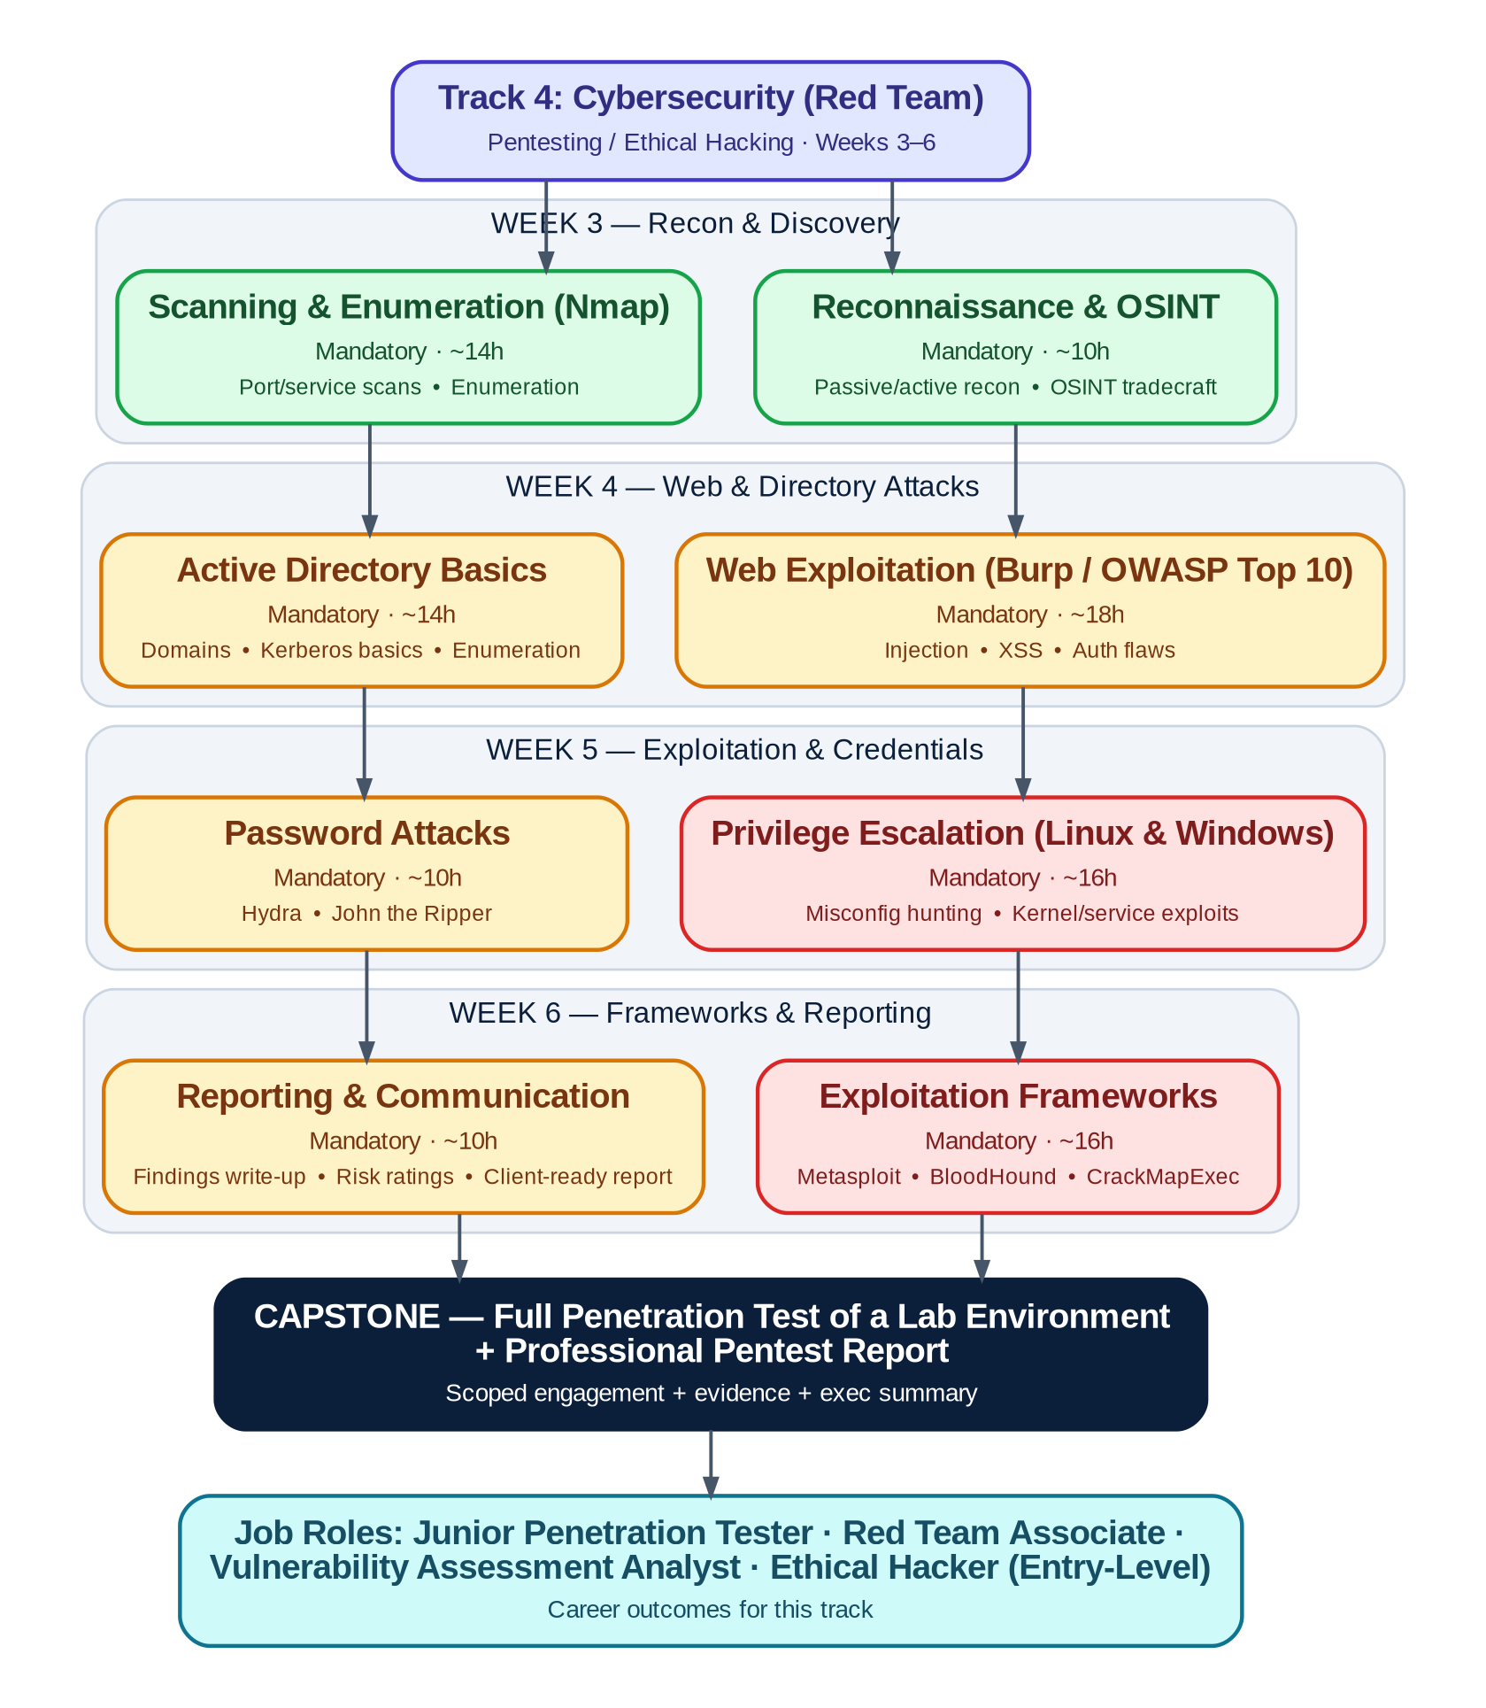
Figure 6 — Red Team track roadmap: Weeks 3–6 from reconnaissance to a full penetration-test capstone

7.4 Topic Breakdown

7.4.1 Reconnaissance & OSINT
● BEGINNER MANDATORY ~10h Prereq: Phase 1 Cybersecurity Fundamentals
Every real engagement starts here — understanding the target before touching it.
Covers: Passive vs. active reconnaissance • OSINT tradecraft • Scope discipline
Hands-on labs:

Resources:
- Official Docs: OWASP Testing Guide
- Free Course: TryHackMe
- Hands-on / Practice: OSINT Framework

7.4.2 Scanning & Enumeration (Nmap)
● BEGINNER MANDATORY ~14h Prereq: Reconnaissance & OSINT
Turns a target IP range into a concrete list of services and versions worth investigating.
Covers: Port/service scanning • Version & OS fingerprinting • Nmap scripting engine (NSE)
Hands-on labs:

Resources:
- Official Docs: Nmap Reference Guide
- Hands-on / Practice: HackTheBox Academy — course catalogue

7.4.3 Web Exploitation (Burp Suite / OWASP Top 10)
● INTERMEDIATE MANDATORY ~18h Prereq: Scanning & Enumeration (Nmap)
The highest-volume vulnerability class in real engagements, and where Burp Suite becomes second nature.
Covers: Injection (SQLi, command injection) • Cross-Site Scripting (XSS) • Authentication & session flaws • OWASP Top 10 mapping
Hands-on labs:

Resources:
- Official Docs: OWASP Top 10
- Free Course: PortSwigger Web Security Academy (free)
- Hands-on / Practice: PortSwigger Web Security Academy (free)

7.4.4 Active Directory Basics
● INTERMEDIATE MANDATORY ~14h Prereq: Web Exploitation
Most enterprise internal engagements are, in practice, an Active Directory engagement.
Covers: AD domains, trusts & Kerberos basics • Enumeration with NetExec/BloodHound
Hands-on labs:

Resources:
- Official Docs: BloodHound Documentation
- Hands-on / Practice: HackTheBox Academy — Penetration Tester path
- Repository: BloodHound (GitHub)

7.4.5 Privilege Escalation (Linux & Windows)
● ADVANCED MANDATORY ~16h Prereq: Active Directory Basics
Getting in is half the job — privilege escalation is what turns initial access into real impact.
Covers: Linux misconfiguration hunting (SUID, cron, PATH) • Windows service/kernel misconfigurations
Hands-on labs:

Resources:
- Official Docs: GTFOBins (Linux living-off-the-land binaries)
- Hands-on / Practice: HackTheBox Academy — Penetration Tester path

7.4.6 Password Attacks
● INTERMEDIATE MANDATORY ~10h Prereq: Privilege Escalation
Weak or reused credentials remain one of the most reliable ways into a network.
Covers: Online brute-force (Hydra) • Offline hash cracking (John the Ripper) • Password-spraying discipline
Hands-on labs:

Resources:
- Official Docs: John the Ripper — Openwall
- Repository: THC-Hydra (GitHub)

7.4.7 Exploitation Frameworks
● ADVANCED MANDATORY ~16h Prereq: Password Attacks
Brings reconnaissance, vulnerability identification, and privilege escalation together into a single guided workflow.
Covers: Metasploit modules & workflow • BloodHound-guided AD attacks • NetExec (formerly CrackMapExec) for lateral movement
Hands-on labs:

Resources:
- Official Docs: Metasploit Documentation
- Repository: NetExec (GitHub) — formerly CrackMapExec

7.4.8 Reporting & Communication
● INTERMEDIATE MANDATORY ~10h Prereq: Exploitation Frameworks
A finding nobody can act on isn't a finding — this is the skill that makes the rest of the track employable.
Covers: Findings write-up structure • Risk ratings (CVSS) • Client-ready executive summaries
Hands-on labs:

Resources:
- Official Docs: Penetration Testing Execution Standard (PTES)
- Free Course: OWASP Testing Guide

7.5 Weekly Milestones
Week | Focus & Objective | Key Deliverable | Checkpoint
Wk 3 | Recon/OSINT and scanning/enumeration methodology established | Full service inventory + OSINT profile for lab target | Lab review + quiz
Wk 4 | Web exploitation and AD enumeration operational | Mini-Project 1: Web app compromise report | Mini-project demo
Wk 5 | Privilege escalation and password attacks practiced on Linux & Windows | Mini-Project 2: Full privesc chain, both OS | Mini-project demo + peer review
Wk 6 | Exploitation frameworks and reporting brought together | Capstone: full penetration test + report | Capstone showcase

7.6 Sample Daily Activities
Representative week (Week 4) — the same daily rhythm (concept → guided lab → independent practice) repeats each week with new topics.
Day | Concept Block (AM) | Guided Lab (PM) | Independent Practice / Output
Mon | OWASP Top 10: injection & XSS theory | Exploit an injection flaw with Burp Suite | Documented exploitation steps + screenshots
Tue | Authentication/session flaw theory | Complete 3 PortSwigger Academy labs | Lab completion certificates + notes
Wed | Active Directory concepts & Kerberos basics | Enumerate lab AD with NetExec + BloodHound | BloodHound attack-path screenshot + explanation
Thu | Report-writing standards (CVSS, risk framing) | Draft findings section for Week 4 vulnerabilities | Peer-reviewed findings write-up
Fri | Week 4 review + mentor office hours | Mini-Project 1 build & polish | Mini-Project 1 live demo + weekly quiz

7.7 Mini-Projects

Mini-Project 1: Web Application Compromise Report (end of Week 4)
Against a deliberately vulnerable lab web application, identify and exploit at least 3 distinct OWASP Top 10 vulnerabilities using Burp Suite, then write a findings report for each with risk rating and remediation advice.
Deliverable: Findings report (3+ vulnerabilities) + Burp Suite evidence exports + retest notes.

Mini-Project 2: Full Privilege-Escalation Chain — Linux & Windows (end of Week 5)
On both a Linux and a Windows lab target, gain initial low-privilege access and escalate to full administrative control, documenting every step and technique used.
Deliverable: Two escalation write-ups (one per OS) with commands, screenshots, and technique explanations.

7.8 Assessment Checkpoints
Checkpoint | Covers | Format | Weight
Weekly Labs (4 sets) | That week's cluster topics | Evidence export + mentor review | 35%
Weekly Quiz (×4) | Concepts from that week | 20 MCQ/short-answer, 30 min | 15%
Mini-Project 1 & 2 | Weeks 4–5 integrated skills | Findings report + live walkthrough | 25%
Capstone | Full track | Live demo + full pentest report | 25%

7.9 Capstone Project

Full Penetration Test of a Lab Environment + Professional Report
Working individually under a signed mock "Rules of Engagement," each intern performs a complete black-box-to-grey-box penetration test of a multi-host lab environment (mixed Linux/Windows, at least one web application, basic AD) and delivers a professional report as if for a paying client.
Requirements:
- Full recon-to-report methodology followed and documented (recon → scanning → exploitation → post-exploitation → reporting).
- At least one web-application vulnerability and one host/OS-level compromise, each fully chained to demonstrated impact.
- Every action stays within the signed scope document — no out-of-scope testing.
- Findings rated with CVSS and prioritized by business risk, not just technical severity.
- A professional report including executive summary, technical findings, and remediation roadmap.
Deliverables:
- Signed scope / rules-of-engagement document.
- Full technical findings log with evidence.
- Professional penetration-test report (executive summary + technical detail).
- 15-minute live demo of the primary attack chain.
Evaluation: Scored against the Capstone Evaluation Rubric in Section 9.5 across methodology rigor, technical depth, scope discipline, and report quality.

7.10 Career Outcomes
This track prepares interns for entry-level roles such as: Junior Penetration Tester · Red Team Associate · Vulnerability Assessment Analyst · Ethical Hacker (Entry-Level)

8. Track 5 — R&D (Research & Development)
Pick an emerging-technology domain, run it like a real R&D sprint, and ship a working prototype — not just a tutorial follow-along.
Field | Detail
Duration | 4 weeks (Weeks 3–6)
Prerequisites | Phase 1 complete — especially Python Programming; domain-specific prerequisites noted per domain below
Estimated Study Hours | ~110–120 hours across 4 weeks (domain-dependent)
Target Job Roles | Junior AI/ML Engineer · Mobile App Developer (Android/iOS) · DevSecOps Engineer · QA/Automation Engineer · R&D / Innovation Associate

8.1 Learning Objectives
- Scope a research/build problem properly: feasibility check, success criteria, and a realistic 4-week plan.
- Reach working proficiency in one chosen emerging-technology domain (AI, Android, iOS, DevSecOps, or Automation).
- Apply engineering rigor — version control, testing, documentation — to exploratory, less-defined R&D work.
- Build a working prototype that demonstrates the chosen domain's core skills end-to-end.
- Communicate technical findings and a working demo clearly to a non-specialist audience.

8.2 Required Tools
Tool | Purpose
Python + LangChain / Hugging Face | AI/LLM domain: model access, RAG pipelines, agents
Android Studio + Kotlin + Jetpack Compose | Android domain: native app development
Xcode + Swift + SwiftUI | iOS domain: native app development
GitHub Actions / Jenkins + Docker + Kubernetes + Trivy/SonarQube | DevSecOps domain: pipelines with security scanning built in
Selenium / Playwright + PowerShell | Automation domain: test and process automation

8.3 Track Roadmap
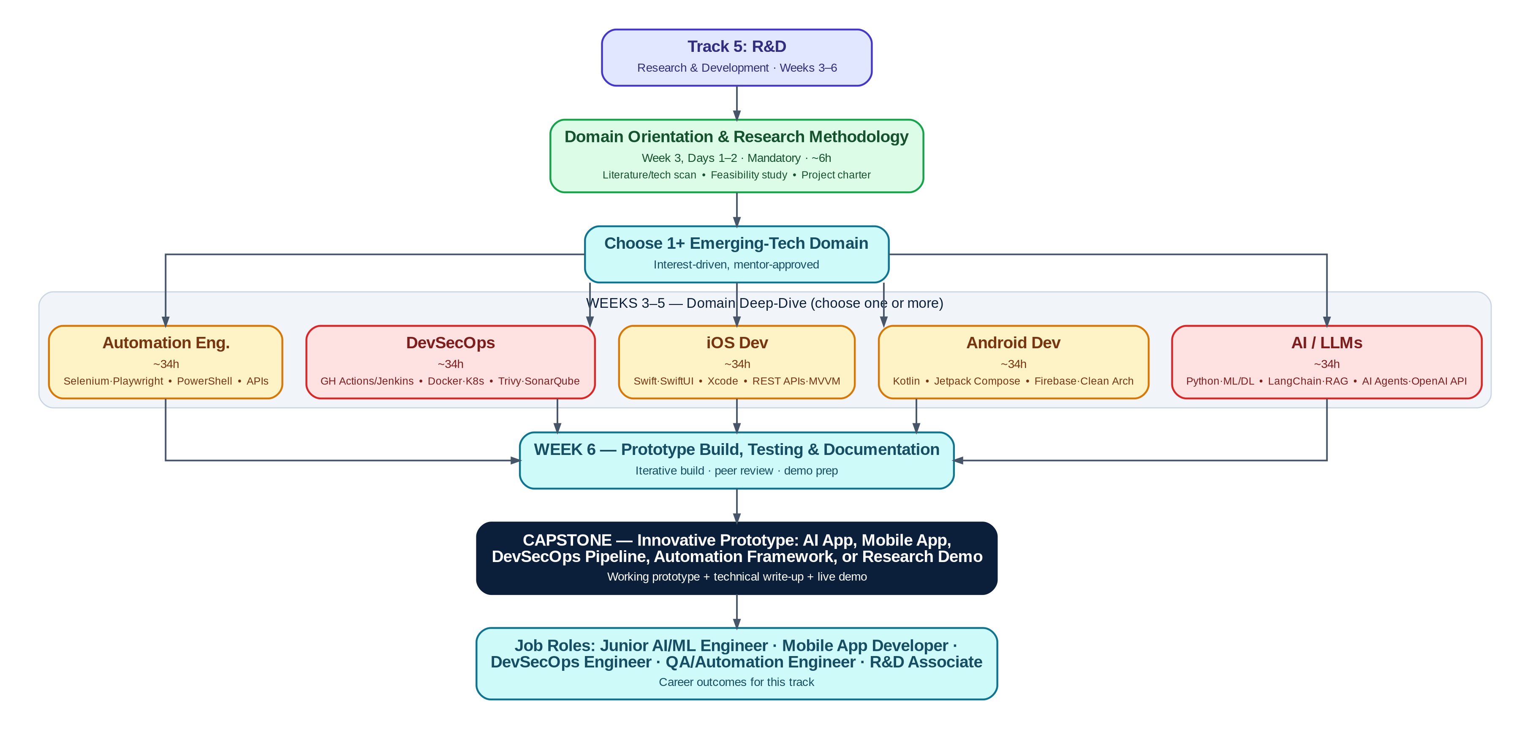
Figure 7 — R&D track roadmap: shared orientation, a chosen domain deep-dive, then a converged prototype capstone

8.4 Topic Breakdown

8.4.1 Domain Orientation & Research Methodology
● BEGINNER MANDATORY ~6h Prereq: Phase 1 Python Programming
Before picking a lane, every intern learns to scope a technical problem like a real R&D engineer would.
Covers: Literature / technology scan • Feasibility study • Writing a one-page project charter
Hands-on labs:

Resources:
- Official Docs: roadmap.sh — role-based roadmaps (browse all domains)

8.4.2 Domain: Artificial Intelligence & LLMs
● ADVANCED OPTIONAL ~34h Prereq: Domain Orientation (select 1+ domains)
Covers classical ML basics fast, then spends most of its time on the LLM application stack interns are most likely to use on the job.
Covers: Advanced Python • Machine Learning / Deep Learning basics • LLMs & Prompt Engineering • LangChain • RAG (Retrieval-Augmented Generation) • AI Agents • OpenAI-compatible APIs
Hands-on labs:

Resources:
- Official Docs: OpenAI API Documentation
- Free Course: roadmap.sh — AI Engineer roadmap
- Hands-on / Practice: Hugging Face — models & datasets
- Repository: LangChain Documentation

8.4.3 Domain: Android Development
● INTERMEDIATE OPTIONAL ~34h Prereq: Domain Orientation (select 1+ domains)
Modern, Kotlin-first native Android development using the current recommended toolkit.
Covers: Kotlin • Android Studio • Jetpack Compose • Firebase • REST APIs • Clean Architecture basics
Hands-on labs:

Resources:
- Official Docs: Android Developers Documentation
- Free Course: roadmap.sh — Android roadmap
- Hands-on / Practice: Kotlin Documentation
- Repository: Firebase Documentation

8.4.4 Domain: iOS Development
● INTERMEDIATE OPTIONAL ~34h Prereq: Domain Orientation (select 1+ domains)
Modern, SwiftUI-first native iOS development using Apple's current recommended toolkit.
Covers: Swift • SwiftUI • Xcode • REST APIs • MVVM architecture
Hands-on labs:

Resources:
- Official Docs: Apple Developer Documentation
- Free Course: Apple — Develop apps for iOS (SwiftUI tutorials)
- Hands-on / Practice: Apple Developer Documentation — Xcode

8.4.5 Domain: DevSecOps
● ADVANCED OPTIONAL ~34h Prereq: Domain Orientation (select 1+ domains); Phase 1 Virtualization & Containers
Builds security scanning into the pipeline itself, rather than bolting it on afterward.
Covers: GitHub Actions / Jenkins • Docker • Kubernetes basics • Security scanning — Trivy, SonarQube
Hands-on labs:

Resources:
- Official Docs: roadmap.sh — DevSecOps roadmap
- Free Course: GitHub Actions Documentation
- Hands-on / Practice: Kubernetes Documentation
- Repository: Trivy (GitHub)

8.4.6 Domain: Automation Engineering
● INTERMEDIATE OPTIONAL ~34h Prereq: Domain Orientation (select 1+ domains)
Builds the test-automation and process-automation skills that keep QA and IT-ops teams sane.
Covers: Selenium • Playwright • PowerShell • API test automation
Hands-on labs:

Resources:
- Official Docs: Selenium Documentation
- Free Course: Playwright Documentation
- Hands-on / Practice: PowerShell Documentation (Microsoft Learn)

8.5 Weekly Milestones
Week | Focus & Objective | Key Deliverable | Checkpoint
Wk 3 | Domain chosen; feasibility study and project charter approved by mentor | Project charter + environment set up for chosen domain | Charter review
Wk 4 | Core domain skills built through guided labs | Mini-Project 1: smallest working version of the prototype | Mini-project demo
Wk 5 | Prototype expanded to full planned feature set | Mini-Project 2: feature-complete prototype (pre-polish) | Mini-project demo + peer review
Wk 6 | Prototype hardened, tested, documented, and rehearsed for demo | Capstone: finished prototype + technical write-up | Capstone showcase

8.6 Sample Daily Activities
Representative week (Week 4) — the same daily rhythm (concept → guided lab → independent practice) repeats each week with new topics.
Day | Concept Block (AM) | Guided Lab (PM) | Independent Practice / Output
Mon | Domain concept block (varies by chosen domain) | Guided lab implementing that concept | Code committed with tests where applicable
Tue | Domain concept block (continued) | Guided lab implementing that concept | Code committed with tests where applicable
Wed | Integration concept (tying prior labs together) | Build the connecting piece in your prototype | Working integrated slice demoed to a peer
Thu | Code review norms & documentation practice | Refactor + document the week's work | Updated README / technical notes
Fri | Week 4 review + mentor office hours | Mini-Project 1 build & polish | Mini-Project 1 live demo + weekly quiz

8.7 Mini-Projects

Mini-Project 1: Smallest Working Prototype (end of Week 4)
Build the smallest possible end-to-end version of your capstone idea — every layer present (e.g., for AI: ingest → retrieve → generate; for Android/iOS: UI → API call → display; for DevSecOps: commit → build → scan → deploy) even if each layer is minimal.
Deliverable: Working code repository + a 3-minute walkthrough demo.

Mini-Project 2: Feature-Complete Prototype (end of Week 5)
Expand the Week 4 prototype to the full feature set defined in your Week 3 project charter, without yet focusing on polish, edge cases, or performance.
Deliverable: Updated repository + a written list of what's complete vs. what remains for capstone polish.

8.8 Assessment Checkpoints
Checkpoint | Covers | Format | Weight
Weekly Labs / Progress Check (4 sets) | That week's domain progress | Repo review + mentor check-in | 30%
Charter & Feasibility Review | Week 3 planning quality | Written charter + mentor approval | 10%
Mini-Project 1 & 2 | Weeks 4–5 integrated skills | Working prototype + live walkthrough | 30%
Capstone | Full track | Live demo + technical write-up | 30%

8.9 Capstone Project

Innovative Prototype — AI App, Mobile App, DevSecOps Pipeline, Automation Framework, or Research Demo
Individually or in pairs, interns deliver a finished, working prototype in their chosen domain that goes meaningfully beyond a tutorial clone — solving a real (even if small) problem, with the engineering rigor (tests, docs, version control) expected of professional R&D work.
Requirements:
- Prototype implements the full feature set committed to in the Week 3 project charter.
- Code is version-controlled with a clean commit history and a professional README.
- At least basic automated tests or a documented manual test plan.
- A short technical write-up explaining architecture, key decisions, and known limitations.
- A working, demoable build — not slides describing what it would do.
Deliverables:
- Source code repository.
- Technical write-up (architecture + decisions + limitations).
- Test evidence (automated or documented manual).
- 15-minute live demo.
Evaluation: Scored against the Capstone Evaluation Rubric in Section 9.5 across functionality, technical depth, code/engineering quality, and communication.

8.10 Career Outcomes
This track prepares interns for entry-level roles such as: Junior AI/ML Engineer · Mobile App Developer (Android/iOS) · DevSecOps Engineer · QA/Automation Engineer · R&D / Innovation Associate

9. Intern KPI & Evaluation Templates
This section provides the complete set of evaluation templates used to track intern performance across the program — from daily labs through the final capstone. Templates are designed to be copied directly into a spreadsheet or printed for in-person mentor reviews. All templates use the same 1–5 rating scale (defined in Section 9.10) so scores are comparable across weeks and tracks.

9.1 KPI Framework Overview
Every intern is evaluated on a continuous, multi-layered cadence rather than a single end-of-internship test. Each layer feeds into the Final Internship Performance Scorecard (Section 9.7):
- Daily: Lab completion, pass/revise checklist — feeds the Weekly Scorecard's Technical Skill Application score.
- Weekly: Weekly Intern KPI Scorecard (Section 9.2) + track-specific technical add-ons (Section 9.3), completed by the assigned mentor.
- Milestone: Mini-Project Evaluation Rubric (Section 9.4) at the end of Weeks 2, 4, and 5.
- Mid-Point: Mid-Internship Review Form (Section 9.6), end of Week 4.
- Final: Capstone Evaluation Rubric (Section 9.5) + Final Performance Scorecard (Section 9.7), Week 6.
Overall weighting toward the Final Internship Performance Scorecard:
Component | Weight
Daily Labs & Attendance (rolled up weekly) | 15%
Weekly Quizzes | 10%
Weekly KPI Scorecards — professionalism & soft skills | 15%
Mini-Projects (Phase 1 + track-level) | 20%
Capstone Project | 30%
Mentor & Peer Feedback | 10%

9.2 Weekly Intern KPI Scorecard (Template)
To be completed by the assigned mentor at the end of each week, ideally in a short 1:1 with the intern. Takes about 10 minutes.
Intern Name: |  | Track:
Week #: | 1-2 | Mentor:
Date: |  | Overall Weighted Score:

Category | What to Look For | Score (1–5) | Weight | Weighted | Mentor Notes
Attendance & Punctuality | Present and on time for sessions and stand-ups |  | 10%
Technical Skill Application | Accuracy and quality of that week's lab work |  | 25%
Problem-Solving & Initiative | Works through blockers before escalating; proposes ideas |  | 15%
Documentation Quality | READMEs, comments, configs are clear and complete |  | 10%
Communication | Clear written updates and verbal explanations of work |  | 10%
Collaboration / Teamwork | Works well in pair/group labs; helps peers |  | 10%
Professionalism | Conduct, reliability, receptiveness to feedback |  | 10%
Growth vs. Previous Week | Visible improvement on prior week's feedback |  | 10%
Weighted = Score × Weight. Sum the Weighted column and multiply by 20 to express the Overall Weighted Score as a percentage (since 5 × 20 = 100).

9.3 Track-Specific Technical KPI Add-ons (Templates)
Layered on top of the "Technical Skill Application" row in Section 9.2, these track-specific metrics keep evaluation concrete and job-relevant rather than purely subjective.

Track 1 — NOC
Metric | Definition | Score (1–5)
Configuration accuracy | Config matches spec (VLAN/ACL/OSPF correctness) on first review
Mean time to diagnose (MTTD-lab) | Minutes to correctly diagnose a mentor-injected fault
Monitoring dashboard completeness | % of required devices/metrics represented with working alerts
Network uptime maintained | % uptime sustained across lab exercises under fault injection

Track 2 — SOC
Metric | Definition | Score (1–5)
Detection rule quality | True-positive rate of authored Sigma/SIEM rules against test data
Mean time to detect (MTTD-sim) | Minutes from simulated attack start to first correct detection
Mean time to respond (MTTR-sim) | Minutes from detection to containment action in tabletop exercises
Incident report quality | Completeness & clarity of timeline, IOCs, and root cause

Track 3 — Cloud (OpenStack)
Metric | Definition | Score (1–5)
Deployment success rate | % of deployments succeeding without manual rework
IaC code quality | Terraform/Ansible passes lint checks and is idempotent on re-run
HA resilience achieved | Service stays available through a simulated node failure (Y/N + notes)
Runbook / documentation completeness | Deployment and recovery steps fully reproducible by a peer

Track 4 — Red Team
Metric | Definition | Score (1–5)
Valid findings per engagement | Count of confirmed, reproducible vulnerabilities found
Exploitation success within scope | % of identified vulnerabilities successfully (and safely) exploited
Scope discipline | Zero out-of-scope actions — pass/fail gate, any failure reviewed immediately
Report professionalism | Findings are reproducible, risk-rated, and client-ready

Track 5 — R&D
Metric | Definition | Score (1–5)
Prototype functionality completeness | % of charter-committed features working end-to-end
Code / test quality | Tests present (or documented manual test plan) and passing
Innovation & problem-fit | Solution genuinely addresses the stated problem, not a tutorial clone
Technical documentation clarity | A peer could understand the architecture from the write-up alone

9.4 Mini-Project Evaluation Rubric (Template)
Reused for the Phase 1 mini-project and every track-level mini-project — just update the project title and deliverables reviewed.
Project Title: |  | Intern(s):
Track / Phase: |  | Reviewer:

Criterion | 5 – Excellent | 3 – Satisfactory | 1 – Needs Work | Weight | Score
Functionality / Correctness | Fully working, handles edge cases | Works for the main use case | Partially working or broken | 30%
Technical Approach | Efficient, well-reasoned design choices | Reasonable, workable approach | Approach is unclear or fragile | 20%
Documentation | Clear, complete, easy to follow | Present but incomplete | Missing or unclear | 20%
Code / Config Quality | Clean, organized, follows conventions | Functional but messy | Hard to follow or maintain | 15%
Presentation / Demo | Confident, clear, answers questions well | Adequate walkthrough | Unclear or unprepared | 15%

9.5 Capstone Project Evaluation Rubric (Template)
Used for all 5 tracks' capstones. Track-specific evaluators should interpret each criterion through their track's lens (e.g., "Security & Best Practices" means firewall/ACL hygiene for NOC, detection coverage for SOC, secure tenant config for Cloud, etc.).
Intern(s): |  | Track:
Capstone Title: |  | Date:
Evaluator(s): |  | Final Score (/100):

Criterion | Description | Weight | Score (1–5) | Weighted (/20)
Technical Complexity & Completeness | Scope matches or exceeds capstone requirements; all required components present | 25%
Correctness / Functionality | The system/deliverable works as intended, demonstrated live | 20%
Security & Best Practices | Track-appropriate security/quality hygiene applied throughout | 15%
Documentation & Reproducibility | A peer could rebuild or understand the work from the docs alone | 15%
Live Demo & Communication | Clear, confident walkthrough; handles follow-up questions well | 15%
Professionalism & Scope Discipline | Delivered on time, within scope, with professional conduct throughout | 10%
Scoring: Weighted (/20) = Score (1–5) × Weight × 100. Sum all Weighted values for the Final Score out of 100.

9.6 Mid-Internship Review Form (End of Week 4)
A structured checkpoint conversation between mentor and intern, roughly halfway through specialization.
Intern Name: |  | Track:
Mentor: |  | Date:
Average Weekly KPI Score so far (Weeks 3–4): ______ / Mini-Project 1 Score: ______
Key strengths observed so far:

Areas for growth before the capstone:

Is the intern on track for capstone readiness? ☐ On track ☐ On track with support ☐ At risk (escalate)

Specific action plan for Weeks 5–6:

Intern's own comments / requested support:

Mentor signature: _______________________ Intern signature: _______________________

9.7 Final Internship Performance Scorecard & Certificate Eligibility
Completed by the lead mentor in the final days of Week 6, after the capstone showcase.
Intern Name: |  | Track:
Cohort Dates: |  | Evaluator:

Component | Weight | Raw Score | Weighted
Daily Labs & Attendance (avg.) | 15%
Weekly Quizzes (avg.) | 10%
Weekly KPI Scorecards (avg.) | 15%
Mini-Projects (avg., Phase 1 + track) | 20%
Capstone Project | 30%
Mentor & Peer Feedback | 10%
TOTAL | 100%
Final Rating (see Section 9.10 scale): _______________________
Certificate of Completion issued? ☐ Yes ☐ No — see notes below
Notes / standout achievements / recommendation for future roles:

Certificate Eligibility Threshold
- Overall weighted score of 70% or higher, AND
- Capstone project fully delivered and demoed (not a placeholder submission), AND
- No unresolved professional-conduct flags from any Weekly KPI Scorecard or Mid-Internship Review.

9.8 Intern Self-Assessment
Name: |  | Week #: | 1-2

What I learned this week that I'm most confident in:

What still feels shaky or unclear:

One thing I did well this week:

One thing I'd do differently:

Support I'd like from my mentor next week:

Self-rated confidence (1 = not confident, 5 = very confident):
Skill Area | 1 | 2 | 3 | 4 | 5
This week's core technical topic | ☐ | ☐ | ☐ | ☐ | ☐
Tools used this week | ☐ | ☐ | ☐ | ☐ | ☐
Communicating my work to others | ☐ | ☐ | ☐ | ☐ | ☐

9.9 Mentor / Supervisor Weekly Feedback Template
A short structured narrative to accompany the Weekly KPI Scorecard — this is what actually gets read and remembered by the intern.
Intern: |  | Week #:
Mentor: |  | Date:

What went well this week (be specific — cite an example):

What to improve, with one concrete suggestion:

Recommended focus for next week:

Any concerns needing program-lead attention? ☐ No ☐ Yes — notes below

9.10 KPI Rating Scale & Grade Conversion
Score | Rating | Description
5 | Outstanding | Consistently exceeds expectations; work is close to industry-ready quality; proactively helps others.
4 | Exceeds Expectations | Regularly goes beyond the minimum; strong independent problem-solving.
3 | Meets Expectations | Solid, reliable performance at the level expected for an intern at this stage.
2 | Below Expectations | Inconsistent quality or engagement; needs closer support to hit weekly goals.
1 | Needs Significant Improvement | Struggling to meet basic requirements; needs an active improvement plan.
Overall weighted percentage (from Section 9.7) maps to a final program rating as follows:
Overall Score | Final Rating | Typical Outcome
90–100% | Outstanding | Certificate + strong reference + priority consideration for future roles
80–89% | Exceeds Expectations | Certificate + reference
70–79% | Meets Expectations | Certificate issued
55–69% | Needs Improvement | Certificate of Participation only; improvement plan discussed
Below 55% | Unsatisfactory | No certificate; program-lead review

10. Appendices

Appendix A — Consolidated Master Resource List
Every resource cited throughout this roadmap, grouped by category for quick reference. Track-specific context for each link is in its topic cluster in Sections 2 and 4–8.

Official Documentation
Resource | URL
Python | https://docs.python.org/3/
Git | https://git-scm.com/doc
GitHub Docs | https://docs.github.com/en/get-started
Docker | https://docs.docker.com/
Ubuntu | https://help.ubuntu.com/
Cisco Networking Academy | https://www.netacad.com/
Wireshark | https://www.wireshark.org/docs/
NIST Cybersecurity Framework | https://www.nist.gov/cyberframework
NIST CSRC | https://csrc.nist.gov/
MITRE ATT&CK | https://attack.mitre.org/matrices/enterprise/
OWASP Top 10 | https://owasp.org/Top10/
Wazuh | https://documentation.wazuh.com/current/index.html
Elastic (ELK Stack) | https://www.elastic.co/guide/index.html
Splunk | https://docs.splunk.com/Documentation/Splunk
SigmaHQ | https://github.com/SigmaHQ/sigma
OpenStack | https://docs.openstack.org/
Kolla Ansible | https://docs.openstack.org/kolla-ansible/latest/
DevStack | https://docs.openstack.org/devstack/latest/
Zabbix | https://www.zabbix.com/documentation/
Grafana | https://grafana.com/docs/
LibreNMS | https://docs.librenms.org/
Prometheus | https://prometheus.io/docs/
HashiCorp Terraform | https://developer.hashicorp.com/terraform
Ansible | https://docs.ansible.com/
Nmap Reference Guide | https://nmap.org/book/man.html
BloodHound | https://bloodhound.specterops.io/
Metasploit | https://docs.metasploit.com/
GTFOBins | https://gtfobins.github.io/
John the Ripper | https://www.openwall.com/john/
NetExec (formerly CrackMapExec) | https://github.com/Pennyw0rth/NetExec
Android Developers | https://developer.android.com/
Kotlin | https://kotlinlang.org/docs/home.html
Firebase | https://firebase.google.com/docs
Apple Developer Documentation | https://developer.apple.com/documentation/
OpenAI API | https://platform.openai.com/docs
LangChain | https://python.langchain.com/
Hugging Face | https://huggingface.co/
Kubernetes | https://kubernetes.io/docs/home/
Trivy | https://github.com/aquasecurity/trivy
Selenium | https://www.selenium.dev/documentation/
Playwright | https://playwright.dev/
PowerShell (Microsoft Learn) | https://learn.microsoft.com/en-us/powershell/
Sysmon (Sysinternals) | https://learn.microsoft.com/en-us/sysinternals/downloads/sysmon
Markdown Guide | https://www.markdownguide.org/

Free Courses & Learning Platforms
Resource | URL
Linux Foundation — Introduction to Linux (LFS101) | https://training.linuxfoundation.org/training/introduction-to-linux/
freeCodeCamp | https://www.freecodecamp.org/
Cisco Skills for All | https://www.netacad.com/
PortSwigger Web Security Academy | https://portswigger.net/web-security
roadmap.sh | https://roadmap.sh/
roadmap.sh — DevSecOps | https://roadmap.sh/devsecops
roadmap.sh — AI Engineer | https://roadmap.sh/ai-engineer
roadmap.sh — Android | https://roadmap.sh/android
Atlassian Agile Coach | https://www.atlassian.com/agile
GitHub Skills | https://skills.github.com/
Real Python | https://realpython.com/

Hands-On Practice Platforms
Resource | URL
OverTheWire — Bandit wargame | https://overthewire.org/wargames/bandit/
TryHackMe | https://tryhackme.com/
HackTheBox Academy | https://academy.hackthebox.com/catalogue/paths
LetsDefend | https://letsdefend.io/
MITRE ATT&CK Navigator | https://mitre-attack.github.io/attack-navigator/
Play with Docker | https://labs.play-with-docker.com/
OSINT Framework | https://osintframework.com/
Wireshark Sample Captures | https://wiki.wireshark.org/SampleCaptures
VirusTotal | https://www.virustotal.com/

Repositories
Resource | URL
first-contributions (beginner PR practice) | https://github.com/firstcontributions/first-contributions
openstack/kolla-ansible | https://github.com/openstack/kolla-ansible
BloodHound | https://github.com/SpecterOps/BloodHound
THC-Hydra | https://github.com/vanhauser-thc/thc-hydra
NetExec | https://github.com/Pennyw0rth/NetExec
Trivy | https://github.com/aquasecurity/trivy

Certifications (Optional)
Certification | URL
CompTIA (Linux+, Network+, Security+) | https://www.comptia.org/
Cisco CCNA | https://www.cisco.com/site/us/en/learn/training-certifications/certifications/enterprise/ccna/index.html
Certifications are optional stretch goals, not program requirements. Interns interested in pursuing one should discuss timing with their mentor — most are best attempted after, not during, the internship.

Appendix B — Required Tools & Software Checklist
For lab-environment setup ahead of Day 1. All tools are free / open-source or have a free tier sufficient for this program.

Phase 1 — All Interns
Tool | Used For
VirtualBox or VMware Workstation Player | Local VM hosting for Linux/Docker labs
A Linux distribution ISO (e.g., Ubuntu Server/Desktop) | Primary Linux lab environment
Wireshark | Packet capture and analysis
Cisco Packet Tracer | Basic networking topology labs
Python 3.x + pip | Programming and automation labs
Git + a GitHub account | Version control for every deliverable
Docker Desktop / Docker Engine | Containerization labs
A code editor (e.g., VS Code) | Writing scripts, configs, and documentation

Track 1 — NOC
- Cisco Packet Tracer
- GNS3 (+ a router/switch image set)
- Wireshark
- Zabbix
- Grafana
- LibreNMS

Track 2 — SOC
- Wazuh
- ELK Stack (Elasticsearch, Logstash, Kibana)
- Splunk (free tier)
- Microsoft Sentinel (trial/lab tenant)
- Velociraptor
- Sysmon
- VirusTotal account

Track 3 — Cloud (OpenStack)
- DevStack-compatible Linux VM (min. 8GB RAM recommended)
- Kolla-Ansible
- OpenStack CLI (python-openstackclient)
- Terraform
- Ansible
- Prometheus + Grafana

Track 4 — Red Team
- Kali Linux (VM or bare metal)
- Burp Suite Community Edition
- Metasploit Framework
- BloodHound + Neo4j
- NetExec
- Gobuster
- Hydra
- John the Ripper

Track 5 — R&D
- Domain-dependent — see below
R&D domain-specific tools: AI/LLMs — Python, LangChain, Hugging Face account, OpenAI-compatible API key. Android — Android Studio, Kotlin. iOS — Xcode (macOS required), Swift. DevSecOps — GitHub Actions or Jenkins, Docker, Kubernetes (e.g., kind/minikube), Trivy, SonarQube (Community Edition). Automation — Selenium or Playwright, PowerShell.

Appendix C — Glossary of Acronyms
Term | Meaning
ACL | Access Control List — rules that permit or deny traffic
AD | Active Directory — Microsoft's directory service for Windows networks
API | Application Programming Interface
ATT&CK | Adversarial Tactics, Techniques & Common Knowledge (MITRE framework)
CIA Triad | Confidentiality, Integrity, Availability — core security model
CI/CD | Continuous Integration / Continuous Deployment
CLI | Command-Line Interface
CVSS | Common Vulnerability Scoring System
DHCP | Dynamic Host Configuration Protocol
DNS | Domain Name System
EDR | Endpoint Detection & Response
ELK | Elasticsearch, Logstash, Kibana (log analytics stack)
HA | High Availability
HOT | Heat Orchestration Template (OpenStack)
IaC | Infrastructure as Code
IaaS | Infrastructure as a Service
IOC | Indicator of Compromise
IR | Incident Response
IPsec | Internet Protocol Security (VPN encryption standard)
LLM | Large Language Model
MTTD / MTTR | Mean Time to Detect / Mean Time to Respond (or Repair)
MVVM | Model-View-ViewModel (software architecture pattern)
NAT / PAT | Network Address Translation / Port Address Translation
NOC | Network Operations Center
NSE | Nmap Scripting Engine
OSI Model | Open Systems Interconnection model (7-layer networking reference)
OSINT | Open-Source Intelligence
OSPF | Open Shortest Path First (routing protocol)
PKI | Public Key Infrastructure
PTES | Penetration Testing Execution Standard
RAG | Retrieval-Augmented Generation
REST | Representational State Transfer (API architecture style)
SIEM | Security Information & Event Management
SNMP | Simple Network Management Protocol
SOAR | Security Orchestration, Automation & Response
SOC | Security Operations Center
SSH | Secure Shell
STP | Spanning Tree Protocol
TCP/IP | Transmission Control Protocol / Internet Protocol
VLAN | Virtual Local Area Network
VPN | Virtual Private Network

